Form 990  Department of the Treasury  Internal Revenue Service | Return of Organization Exempt From Income Tax  Under section 501(c), 527, or 4947(a)(1) of the Internal Revenue Code (except private foundations) Do not enter social security numbers on this form as it may be made public.  Go to www.irs.gov/Form990 for instructions and the latest information. | OMB No. 1545-0047
 |  | 2023
 |  | Open to Public Inspection
- For the 2023 calendar year, or tax year beginning JUL 1, 2023 and ending JUN 30, 2024
- Check if C Name of organization D Employer identification number applicable:
^{Address}change HOUR CHILDREN, INC.
^{Name}change Doing business as **-***7412
Initial
return Number and street (or P.O. box if mail is not delivered to street address) Room/suite E Telephone number
^{Final}return/ 36-11 12TH STREET 718-433-4724
^{termin-}ated City or town, state or province, country, and ZIP or foreign postal code G Gross receipts $ 11,350,425.
X Amendedreturn LONG ISLAND CITY, NY 11106 H(a) Is this a group return
Applica-tion F Name and address of principal officer:ALETHEA TAYLOR for subordinates?~~ Yes X No
pending
H(b) Are all subordinates included? Yes No
- Tax-exempt status: X 501(c)(3) 501(c) ( ) (insert no.) 4947(a)(1) or 527 If "No," attach a list. See instructions
- Website: WWW.HOURCHILDREN.ORG H(c) Group exemption number
- Form of organization: X Corporation Trust Association Other L Year of formation: M State of legal domicile: NY

Part I Summary
- Briefly describe the organization’s mission or most significant activities: HOUR CHILDREN’S MISSION IS TO
HELP INCARCERATED AND FORMERLY INCARCERATED WOMEN AND THEIR CHILDREN
- Check this box if the organization discontinued its operations or disposed of more than 25% of its net assets.
- Number of voting members of the governing body (Part VI, line 1a) ~~~~~~~~~~~~~~~~~~~~ 3 9 4 Number of independent voting members of the governing body (Part VI, line 1b) ~~~~~~~~~~~~~~ 4 9 5 Total number of individuals employed in calendar year 2023 (Part V, line 2a) ~~~~~~~~~~~~~~~~ 5 94 6 Total number of volunteers (estimate if necessary)~~~~~~~~~~~~~~~~~~~~~~~~~~~~~ 6 0
- a Total unrelated business revenue from Part VIII, column (C), line 12 ~~~~~~~~~~~~~~~~~~~~ 7a 0. b Net unrelated business taxable income from Form 990-T, Part I, line 11 7_{b} 0. Prior Year Current Year
- Contributions and grants (Part VIII, line 1h) ~~~~~~~~~~~~~~~~~~~~~ 5,472,880. 4,570,480.
- Program service revenue (Part VIII, line 2g) ~~~~~~~~~~~~~~~~~~~~~ 834,926. 791,228.
- Investment income (Part VIII, column (A), lines 3, 4, and 7d) ~~~~~~~~~~~~~ 1,071,082. 477,077. 11 Other revenue (Part VIII, column (A), lines 5, 6d, 8c, 9c, 10c, and 11e) ~~~~~~~~ 584,413. 477,609. 12 Total revenue - add lines 8 through 11 (must equal Part VIII, column (A), line 12) 7,963,301. 6,316,394.
- Grants and similar amounts paid (Part IX, column (A), lines 1-3) ~~~~~~~~~~~ 0. 0.
- Benefits paid to or for members (Part IX, column (A), line 4) ~~~~~~~~~~~~~ 0. 0. 15 Salaries, other compensation, employee benefits (Part IX, column (A), lines 5-10) ~~~ 3,363,668. 4,083,774.
16a Professional fundraising fees (Part IX, column (A), line 11e)~~~~~~~~~~~~~~ 0. 0. b Total fundraising expenses (Part IX, column (D), line 25) 483,544.
17 Other expenses (Part IX, column (A), lines 11a-11d, 11f-24e) ~~~~~~~~~~~~~ 2,903,756. 2,857,328. 18 Total expenses. Add lines 13-17 (must equal Part IX, column (A), line 25) ~~~~~~~ 6,267,424. 6,941,102.
19 Revenue less expenses. Subtract line 18 from line 12 1,695,877. -624,708.

Beginning of Current Year End of Year
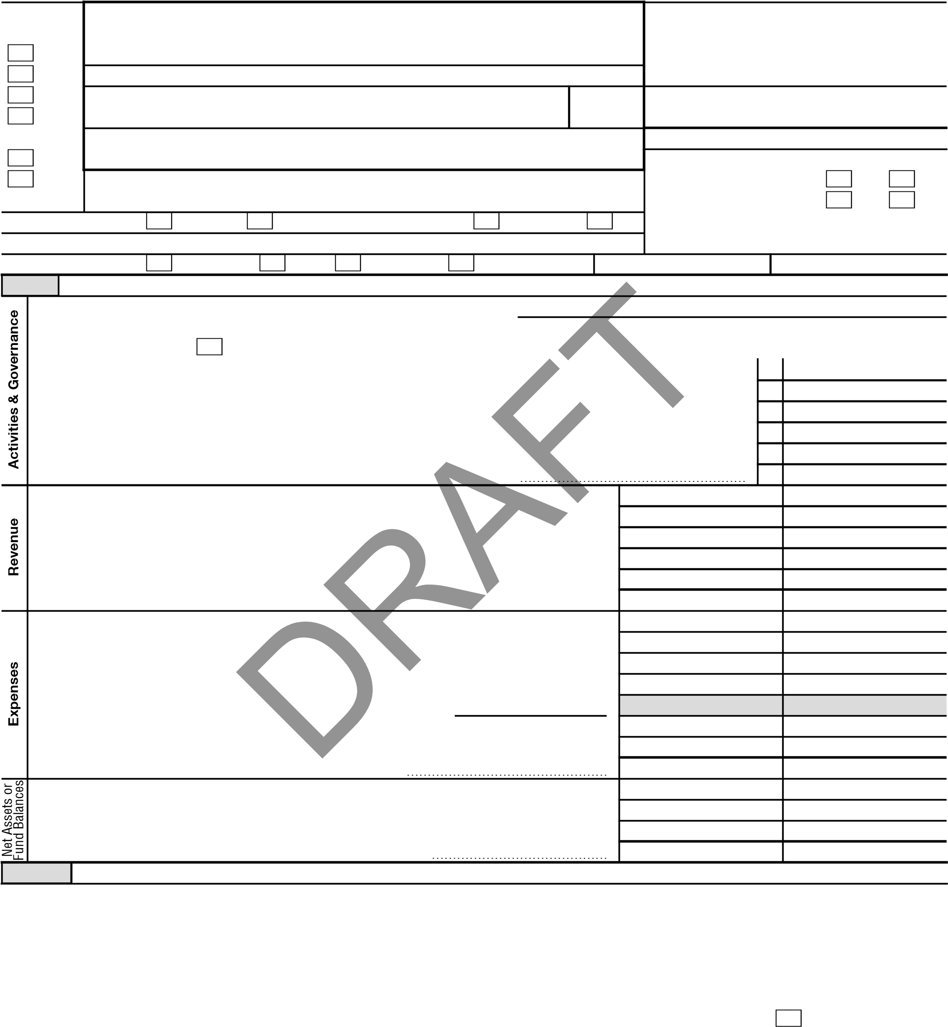
20 Total assets (Part X, line 16) ~~~~~~~~~~~~~~~~~~~~~~~~~~~~ 21,078,178. 20,732,087. 21 Total liabilities (Part X, line 26) ~~~~~~~~~~~~~~~~~~~~~~~~~~~ 2,631,849. 2,132,121. 22 Net assets or fund balances. Subtract line 21 from line 20 18,446,329. 18,599,966. Part II Signature Block
Under penalties of perjury, I declare that I have examined this return, including accompanying schedules and statements, and to the best of my knowledge and belief, it is true, correct, and complete. Declaration of preparer (other than officer) is based on all information of which preparer has any knowledge.
Sign
Here
Sign  Here | Signature of officer Date ALETHEA TAYLOR, EXECUTIVE DIRECTOR
Sign  Here | Type or print name and title
Paid  Preparer  Use Only | Print/Type preparer’s name MESUG KIM | Preparer’s signature | Date 07/16/25 |  | Check  if  self-employed | PTIN P01291883
Paid  Preparer  Use Only | Firm’s name LIPSKY GOODKIN & CO P.C. |  |  | Firm’s EIN **-***2154
Paid  Preparer  Use Only | Firm’s address 120 WEST 45TH STREET 7TH FL NEW YORK, NY 10036 |  |  | Phone no.(212)840-6444
May the IRS discuss this return with the preparer shown above? See instructions Yes No LHA For Paperwork Reduction Act Notice, see the separate instructions. 332001 12-21-23 (2023) SEE SCHEDULE O FOR ORGANIZATION MISSION STATEMENT CONTINUATION
2
Part III | Statement of Program Service Accomplishments  Check if Schedule O contains a response or note to any line in this Part III | X
1 Briefly describe the organization’s mission:
HOUR CHILDREN IS COMMITTED TO THE COMPASSIONATE AND LOVING CARE OF
CHILDREN OF INCARCERATED WOMEN. OUR OUTREACH INCLUDES SUPPORT AND
EMPOWERMENT FOR MOTHERS UPON REUNIFICATION WITH THEIR FAMILIES. ALL
PERSONS ARE ENCOURAGED TO LIVE AND INTERACT WITH DIGNITY AND RESPECT.
- Did the organization undertake any significant program services during the year which were not listed on the  prior Form 990 or 990-EZ? ~~~~~~~~~~~~~~~~~~~~~~~~~~~~~~~~~~~~~~~~~~~~~~~ Yes X  If "Yes," describe these new services on Schedule O.  - Did the organization cease conducting, or make significant changes in how it conducts, any program services?~~~~~~ Yes X If "Yes," describe these changes on Schedule O.  - Describe the organization’s program service accomplishments for each of its three largest program services, as measured by expenses. Section 501(c)(3) and 501(c)(4) organizations are required to report the amount of grants and allocations to others, the total expenses, and revenue, if any, for each program service reported. |  | No  No

4a (Code: ) (Expenses $ 5,246,741. _{including grants of $} ) (Revenue $ )
HOUR CHILDREN PROVIDES TRANSITIONAL HOUSING AND SERVICES AT FIVE
LOCATIONS AND PERMANENT HOUSING AT THREE LOCATIONS FOR FORMERLY
INCARCERATED MOTHERS AND CHILDREN.HOUR CHILDREN OFFERS INTENSE CARE
MANAGEMENT TO RESIDENTS INCLUDING COUSELING, JOB READINESS, RELAPSE
PREVENTION SERVICES, BABY SITTING SERVICES, AN AFTER-SCHOOL CLUB, FOOD
PANTRY, AND MENTORING PROGRAMS FOR CHILDREN WHOSE PARENTS ARE
INCARCERATED AND FOR WOMEN UPON REENTRY. HOUR CHILDREN’S TWO THRIFT
SHOPS AND FURNITURE OUTLET OFFER EMPLOYMENT TRAINING TO RESIDENTS WHILE
PROVIDING ORGANIZATIONAL REVENUE AND NEEDED RESOURCES. SERVICES TO THE
LOCAL COMMUNITY INCLUDE THE THRIFT STORES AND COMMUNITY FOOD PANTRY AND
TEEN PROGRAM. HOUR CHILDREN RUNS THE FAMILY SERVICE PROGRAM IN BEDFORD
HILLS AND TACONIC CORRECTIONAL FACICLITIES WHICH INCLUDES A NURSERY
4b (Code: ) (Expenses $ including grants of $ ) (Revenue $ )
4c (Code: ) (Expenses $ including grants of $ ) (Revenue $ )
4d | Other program services (Describe on Schedule O.)  (Expenses $ including grants of $ | ) (Revenue $ | )
4e | Total program service expenses 5,246,741.
Form 990 (2023)
- 12-21-23 SEE SCHEDULE O FOR CONTINUATION(S)
3
Part IV | Checklist of Required Schedules
 |  |  | Yes | No
- Is the organization described in section 501(c)(3) or 4947(a)(1) (other than a private foundation)?  If "Yes," complete Schedule A~~~~~~~~~~~~~~~~~~~~~~~~~~~~~~~~~~~~~~~~~~~~~~~  - Is the organization required to complete Schedule B, Schedule of Contributors? See instructions ~~~~~~~~~~~~~~  - Did the organization engage in direct or indirect political campaign activities on behalf of or in opposition to candidates for  public office? If "Yes," complete Schedule C, Part I ~~~~~~~~~~~~~~~~~~~~~~~~~~~~~~~~~~~~  - Section 501(c)(3) organizations. Did the organization engage in lobbying activities, or have a section 501(h) election in effect during the tax year? If "Yes," complete Schedule C, Part II~~~~~~~~~~~~~~~~~~~~~~~~~~~~~~~~~  - Is the organization a section 501(c)(4), 501(c)(5), or 501(c)(6) organization that receives membership dues, assessments, or similar amounts as defined in Rev. Proc. 98-19? If "Yes," complete Schedule C, Part III~~~~~~~~~~~~~~~~~~~  - Did the organization maintain any donor advised funds or any similar funds or accounts for which donors have the right to provide advice on the distribution or investment of amounts in such funds or accounts? If "Yes," complete Schedule D, Part I  - Did the organization receive or hold a conservation easement, including easements to preserve open space, the environment, historic land areas, or historic structures? If "Yes," complete Schedule D, Part II~~~~~~~~~~~~~~ 8 Did the organization maintain collections of works of art, historical treasures, or other similar assets? If "Yes," complete  Schedule D, Part III ~~~~~~~~~~~~~~~~~~~~~~~~~~~~~~~~~~~~~~~~~~~~~~~~~~~~  - Did the organization report an amount in Part X, line 21, for escrow or custodial account liability; serve as a custodian for amounts not listed in Part X; or provide credit counseling, debt management, credit repair, or debt negotiation services?  If "Yes," complete Schedule D, Part IV~~~~~~~~~~~~~~~~~~~~~~~~~~~~~~~~~~~~~~~~~~~  - Did the organization, directly or through a related organization, hold assets in donor-restricted endowments  or in quasi-endowments? If "Yes," complete Schedule D, Part V ~~~~~~~~~~~~~~~~~~~~~~~~~~~~~~  - If the organization’s answer to any of the following questions is "Yes," then complete Schedule D, Parts VI, VII, VIII, IX, or X, as applicable.  - Did the organization report an amount for land, buildings, and equipment in Part X, line 10? If "Yes," complete Schedule D,  Part VI ~~~~~~~~~~~~~~~~~~~~~~~~~~~~~~~~~~~~~~~~~~~~~~~~~~~~~~~~~~  - Did the organization report an amount for investments - other securities in Part X, line 12, that is 5% or more of its total  assets reported in Part X, line 16? If "Yes," complete Schedule D, Part VII ~~~~~~~~~~~~~~~~~~~~~~~~~  - Did the organization report an amount for investments - program related in Part X, line 13, that is 5% or more of its total assets reported in Part X, line 16? If "Yes," complete Schedule D, Part VIII ~~~~~~~~~~~~~~~~~~~~~~~~~  - Did the organization report an amount for other assets in Part X, line 15, that is 5% or more of its total assets reported in  Part X, line 16? If "Yes," complete Schedule D, Part IX ~~~~~~~~~~~~~~~~~~~~~~~~~~~~~~~~~~~ e Did the organization report an amount for other liabilities in Part X, line 25? If "Yes," complete Schedule D, Part X~~~~~~ f Did the organization’s separate or consolidated financial statements for the tax year include a footnote that addresses the organization’s liability for uncertain tax positions under FIN 48 (ASC 740)? If "Yes," complete Schedule D, Part X ~~~~  DRAFT  12a Did the organization obtain separate, independent audited financial statements for the tax year? If "Yes," complete  Schedule D, Parts XI and XII~~~~~~~~~~~~~~~~~~~~~~~~~~~~~~~~~~~~~~~~~~~~~~~~ b Was the organization included in consolidated, independent audited financial statements for the tax year?  If "Yes," and if the organization answered "No" to line 12a, then completing Schedule D, Parts XI and XII is optional ~~~~~  13 Is the organization a school described in section 170(b)(1)(A)(ii)? If "Yes," complete Schedule E ~~~~~~~~~~~~~~  14a Did the organization maintain an office, employees, or agents outside of the United States? ~~~~~~~~~~~~~~~~ b Did the organization have aggregate revenues or expenses of more than $10,000 from grantmaking, fundraising, business, investment, and program service activities outside the United States, or aggregate foreign investments valued at $100,000  or more? If "Yes," complete Schedule F, Parts I and IV~~~~~~~~~~~~~~~~~~~~~~~~~~~~~~~~~~~  - Did the organization report on Part IX, column (A), line 3, more than $5,000 of grants or other assistance to or for any  foreign organization? If "Yes," complete Schedule F, Parts II and IV ~~~~~~~~~~~~~~~~~~~~~~~~~~~~  - Did the organization report on Part IX, column (A), line 3, more than $5,000 of aggregate grants or other assistance to or for foreign individuals? If "Yes," complete Schedule F, Parts III and IV ~~~~~~~~~~~~~~~~~~~~~~~~~~  - Did the organization report a total of more than $15,000 of expenses for professional fundraising services on Part IX, column (A), lines 6 and 11e? If "Yes," complete Schedule G, Part I. See instructions ~~~~~~~~~~~~~~~~~~~~  - Did the organization report more than $15,000 total of fundraising event gross income and contributions on Part VIII, lines  1c and 8a? If "Yes," complete Schedule G, Part II ~~~~~~~~~~~~~~~~~~~~~~~~~~~~~~~~~~~~~  - Did the organization report more than $15,000 of gross income from gaming activities on Part VIII, line 9a? If "Yes,"  complete Schedule G, Part III ~~~~~~~~~~~~~~~~~~~~~~~~~~~~~~~~~~~~~~~~~~~~~~~  20a Did the organization operate one or more hospital facilities? If "Yes," complete Schedule H~~~~~~~~~~~~~~~~~ b If "Yes" to line 20a, did the organization attach a copy of its audited financial statements to this return? ~~~~~~~~~~  21 Did the organization report more than $5,000 of grants or other assistance to any domestic organization or domestic government on Part IX, column (A), line 1? If "Yes," complete Schedule I, Parts I and II ~~~~~~~~~~~~~~ |  | 1 | X
 |  | 2 | X
 |  | 3 |  | X
 |  | 4 |  | X
 |  | 5 |  | X
 |  | 6 |  | X
 |  | 7 |  | X
 |  | 8 |  | X
 |  | 9 |  | X
 |  | 10 |  | X
 |  | 11a | X
 |  | 11b |  | X
 |  | 11c |  | X
 |  | 11d | X
 |  | 11e | X
 |  | 11f |  | X
 |  | 12a | X
 |  | 12b |  | X
 |  | 13 |  | X
 |  | 14a |  | X
 |  | 14b |  | X
 |  | 15 |  | X
 |  | 16 |  | X
 |  | 17 |  | X
 |  | 18 | X
 |  | 19 |  | X
 |  | 20a |  | X
 |  | 20b
 |  | 21 |  | X
- 12-21-23

4

Part IV Checklist of Required Schedules (continued)
Yes No
- Did the organization report more than $5,000 of grants or other assistance to or for domestic individuals on
Part IX, column (A), line 2? If "Yes," complete Schedule I, Parts I and III ~~~~~~~~~~~~~~~~~~~~~~~~~~ 22 X
- Did the organization answer "Yes" to Part VII, Section A, line 3, 4, or 5, about compensation of the organization’s current and former officers, directors, trustees, key employees, and highest compensated employees? If "Yes," complete
Schedule J ~~~~~~~~~~~~~~~~~~~~~~~~~~~~~~~~~~~~~~~~~~~~~~~~~~~~~~~~ 23 X
24a Did the organization have a tax-exempt bond issue with an outstanding principal amount of more than $100,000 as of the last day of the year, that was issued after December 31, 2002? If "Yes," answer lines 24b through 24d and complete
Schedule K. If "No," go to line 25a~~~~~~~~~~~~~~~~~~~~~~~~~~~~~~~~~~~~~~~~~~~~~ 24a X b Did the organization invest any proceeds of tax-exempt bonds beyond a temporary period exception? ~~~~~~~~~~~ 24b c Did the organization maintain an escrow account other than a refunding escrow at any time during the year to defease
any tax-exempt bonds? ~~~~~~~~~~~~~~~~~~~~~~~~~~~~~~~~~~~~~~~~~~~~~~~~~~ 24c d Did the organization act as an "on behalf of" issuer for bonds outstanding at any time during the year?~~~~~~~~~~~ 24d

25a Section 501(c)(3), 501(c)(4), and 501(c)(29) organizations. Did the organization engage in an excess benefit transaction with a disqualified person during the year? If "Yes," complete Schedule L, Part I ~~~~~~~~~~~~~~~~ 25a X b Is the organization aware that it engaged in an excess benefit transaction with a disqualified person in a prior year, and that the transaction has not been reported on any of the organization’s prior Forms 990 or 990-EZ? If "Yes," complete
Schedule L, Part I ~~~~~~~~~~~~~~~~~~~~~~~~~~~~~~~~~~~~~~~~~~~~~~~~~~~~ 25b X
- Did the organization report any amount on Part X, line 5 or 22, for receivables from or payables to any current or former officer, director, trustee, key employee, creator or founder, substantial contributor, or 35%
controlled entity or family member of any of these persons? If "Yes," complete Schedule L, Part II ~~~~~~~~~~~~~ 26 X
- Did the organization provide a grant or other assistance to any current or former officer, director, trustee, key employee, creator or founder, substantial contributor or employee thereof, a grant selection committee member, or to a 35% controlled entity (including an employee thereof) or family member of any of these persons? If "Yes," complete Schedule L, Part III~~~ 27 X
- Was the organization a party to a business transaction with one of the following parties? (See the Schedule L, Part IV, instructions for applicable filing thresholds, conditions, and exceptions):
a A current or former officer, director, trustee, key employee, creator or founder, or substantial contributor? If
"Yes," complete Schedule L, Part IV~~~~~~~~~~~~~~~~~~~~~~~~~~~~~~~~~~~~~~~~~~~~ 28a X b A family member of any individual described in line 28a? If "Yes," complete Schedule L, Part IV~~~~~~~~~~~~~~~ 28b X c A 35% controlled entity of one or more individuals and/or organizations described in line 28a or 28b? If
"Yes," complete Schedule L, Part IV~~~~~~~~~~~~~~~~~~~~~~~~~~~~~~~~~~~~~~~~~~~~ 28c X
- Did the organization receive more than $25,000 in noncash contributions? If "Yes," complete Schedule M ~~~~~~~~~ 29 X
- Did the organization receive contributions of art, historical treasures, or other similar assets, or qualified conservation
contributions? If "Yes," complete Schedule M ~~~~~~~~~~~~~~~~~~~~~~~~~~~~~~~~~~~~~~~ 30 X
- Did the organization liquidate, terminate, or dissolve and cease operations? If "Yes," complete Schedule N, Part I~~~~~~ 31 X
- Did the organization sell, exchange, dispose of, or transfer more than 25% of its net assets? If "Yes," complete
Schedule N, Part II ~~~~~~~~~~~~~~~~~~~~~~~~~~~~~~~~~~~~~~~~~~~~~~~~~~~~ 32 X
- Did the organization own 100% of an entity disregarded as separate from the organization under Regulations
sections 301.7701-2 and 301.7701-3? If "Yes," complete Schedule R, Part I ~~~~~~~~~~~~~~~~~~~~~~~~ 33 X
- Was the organization related to any tax-exempt or taxable entity? If "Yes," complete Schedule R, Part II, III, or IV, and
Part V, line 1 ~~~~~~~~~~~~~~~~~~~~~~~~~~~~~~~~~~~~~~~~~~~~~~~~~~~~~~~ 34 X
35a Did the organization have a controlled entity within the meaning of section 512(b)(13)? ~~~~~~~~~~~~~~~~~~ 35a X b If "Yes" to line 35a, did the organization receive any payment from or engage in any transaction with a controlled entity within the meaning of section 512(b)(13)? If "Yes," complete Schedule R, Part V, line 2 ~~~~~~~~~~~~~~~~~~~ 35b
- Section 501(c)(3) organizations. Did the organization make any transfers to an exempt non-charitable related organization?
If "Yes," complete Schedule R, Part V, line 2 ~~~~~~~~~~~~~~~~~~~~~~~~~~~~~~~~~~~~~~~~ 36 X
- Did the organization conduct more than 5% of its activities through an entity that is not a related organization and that is treated as a partnership for federal income tax purposes? If "Yes," complete Schedule R, Part VI ~~~~~~~~ 37 X
- Did the organization complete Schedule O and provide explanations on Schedule O for Part VI, lines 11b and 19?
Note: All Form 990 filers are required to complete Schedule O 38 X

Part V Statements Regarding Other IRS Filings and Tax Compliance
Check if Schedule O contains a response or note to any line in this Part V
1a Enter the number reported in box 3 of Form 1096. Enter -0- if not applicable ~~~~~~~~~~~ b Enter the number of Forms W-2G included on line 1a. Enter -0- if not applicable~~~~~~~~~~ c Did the organization comply with backup withholding rules for reportable payments to vendors and report (gambling) winnings to prize winners? | 1a | 0 |  | Yes | No
 | 1b | 0
 |  | able gaming
 |  | able gaming | 1c
- 12-21-23
5
Part V | Statements Regarding Other IRS Filings and Tax Compliance(continued)
 |  |  |  |  | Yes | No
2a Enter the number of employees reported on Form W-3, Transmittal of Wage and Tax Statements, filed for the calendar year ending with or within the year covered by this return~~~~~~~~~~  b If at least one is reported on line 2a, did the organization file all required federal employment tax retu  3a Did the organization have unrelated business gross income of $1,000 or more during the year? ~~ b If "Yes," has it filed a Form 990-T for this year? If "No" to line 3b, provide an explanation on Schedule  4a At any time during the calendar year, did the organization have an interest in, or a signature or other financial account in a foreign country (such as a bank account, securities account, or other financial  b If "Yes," enter the name of the foreign country  See instructions for filing requirements for FinCEN Form 114, Report of Foreign Bank and Financial 5a Was the organization a party to a prohibited tax shelter transaction at any time during the tax year? b Did any taxable party notify the organization that it was or is a party to a prohibited tax shelter trans c If "Yes" to line 5a or 5b, did the organization file Form 8886-T?~~~~~~~~~~~~~~~~~~~  6a Does the organization have annual gross receipts that are normally greater than $100,000, and did t any contributions that were not tax deductible as charitable contributions? ~~~~~~~~~~~~  b If "Yes," did the organization include with every solicitation an express statement that such contribu  were not tax deductible? ~~~~~~~~~~~~~~~~~~~~~~~~~~~~~~~~~~~~~  7 Organizations that may receive deductible contributions under section 170(c).  a Did the organization receive a payment in excess of $75 made partly as a contribution and partly for goods and se b If "Yes," did the organization notify the donor of the value of the goods or services provided? ~~~ c Did the organization sell, exchange, or otherwise dispose of tangible personal property for which it w to file Form 8282?  - If "Yes," indicate the number of Forms 8282 filed during the year ~~~~~~~~~~~~~~~~    - Did the organization receive any funds, directly or indirectly, to pay premiums on a personal benefit f Did the organization, during the year, pay premiums, directly or indirectly, on a personal benefit cont g If the organization received a contribution of qualified intellectual property, did the organization file F h If the organization received a contribution of cars, boats, airplanes, or other vehicles, did the organiz  8 Sponsoring organizations maintaining donor advised funds. Did a donor advised fund maintaine sponsoring organization have excess business holdings at any time during the year? ~~~~~~~ 9 Sponsoring organizations maintaining donor advised funds.  a Did the sponsoring organization make any taxable distributions under section 4966? ~~~~~~~ b Did the sponsoring organization make a distribution to a donor, donor advisor, or related person? ~ 10 Section 501(c)(7) organizations. Enter:  a Initiation fees and capital contributions included on Part VIII, line 12 ~~~~~~~~~~~~~~~ b Gross receipts, included on Form 990, Part VIII, line 12, for public use of club facilities ~~~~~~ 11 Section 501(c)(12) organizations. Enter:  a Gross income from members or shareholders ~~~~~~~~~~~~~~~~~~~~~~~~~~ b Gross income from other sources. (Do not net amounts due or paid to other sources against  amounts due or received from them.) ~~~~~~~~~~~~~~~~~~~~~~~~~~~~~~  12a Section 4947(a)(1) non-exempt charitable trusts. Is the organization filing Form 990 in lieu of Form b If "Yes," enter the amount of tax-exempt interest received or accrued during the year 13 Section 501(c)(29) qualified nonprofit health insurance issuers.  - Is the organization licensed to issue qualified health plans in more than one state?~~~~~~~~~ Note: See the instructions for additional information the organization must report on Schedule O. b Enter the amount of reserves the organization is required to maintain by the states in which the organization is licensed to issue qualified health plans ~~~~~~~~~~~~~~~~~~~~~~ c Enter the amount of reserves on hand~~~~~~~~~~~~~~~~~~~~~~~~~~~~~~  14a Did the organization receive any payments for indoor tanning services during the tax year?  - If "Yes," has it filed a Form 720 to report these payments? If "No," provide an explanation on Schedule O  - Is the organization subject to the section 4960 tax on payment(s) of more than $1,000,000 in remuneration or  excess parachute payment(s) during the year?~~~~~~~~~~~~~~~~~~~~~~~~~~~~~~~~~~~~~~~  If "Yes," see the instructions and file Form 4720, Schedule N.  - Is the organization an educational institution subject to the section 4968 excise tax on net investment income? If "Yes," complete Form 4720, Schedule O.  - Section 501(c)(21) organizations. Did the trust, or any disqualified or other person engage in any activities that would result in the imposition of an excise tax under section 4951, 4952 or 4953? If "Yes," complete Form 6069. |  | 2a | 94
 |  | rns?~  ~~~ O ~  autho accou  Accou  ~~~ action?  ~~~  he org  ~~~  tions  ~~~  rvices  ~~~ as re  7d | ~~~~~~~~~  ~~~~~~~~~  ~~~~~~~~~  rity over, a  nt)?~~~~~~~  nts (FBAR).  ~~~~~~~~~  ~~~~~~~~~  ~~~~~~~~~  anization solicit  ~~~~~~~~~  or gifts  ~~~~~~~~~  provided to the payor?  ~~~~~~~~~  quired | 2b | X
 |  |  |  | 3a |  | X
 |  |  |  | 3b
 |  |  |  | 4a |  | X
 |  |  |  | 5a |  | X
 |  |  |  | 5b |  | X
 |  |  |  | 5c
 |  |  |  | 6a |  | X
 |  |  |  | 6b
 |  |  |  | 7a |  | X
 |  |  |  | 7b
 |  |  |  | 7c |  | X
 |  | contra ract? orm 8  ation f  d by th  ~~~  ~~~  ~~~  10a | ct? ~~~~~~~  ~~~~~~~~~  899 as required?~ ile a Form 1098-C? e  ~~~~~~~~~  ~~~~~~~~~  ~~~~~~~~~ | 7e
 |  | contra ract? orm 8  ation f  d by th  ~~~  ~~~  ~~~  10a |  | 7f
 |  | contra ract? orm 8  ation f  d by th  ~~~  ~~~  ~~~  10a |  | 7g
 |  | contra ract? orm 8  ation f  d by th  ~~~  ~~~  ~~~  10a |  | 7h
 |  | contra ract? orm 8  ation f  d by th  ~~~  ~~~  ~~~  10a |  | 8
 |  | contra ract? orm 8  ation f  d by th  ~~~  ~~~  ~~~  10a |  | 9a
 |  | contra ract? orm 8  ation f  d by th  ~~~  ~~~  ~~~  10a |  | 9b
 |  | 10b
 |  | 11a
 |  | 11b
 |  | 1041  12b | ? | 12a
 |  | ~~~  13b | ~~~~~~~~~
 |  | ~~~  13b | ~~~~~~~~~ | 13a
 |  | 13c
 |  | ~~~~~~~~~~~~~~~~  ~~~~~~~~~  ~~~~~~  ~~~~~~~~~~~~~~~~~~~ |  | 14a |  | X
 |  |  |  | 14b
 |  |  |  | 15 |  | X
 |  |  |  | 16 |  | X
 |  |  |  | 17
- 12-21-23
6
Part VI | Governance, Management, and Disclosure. For each "Yes" response to lines 2 through 7b below, and for a "No" response to line 8a, 8b, or 10b below, describe the circumstances, processes, or changes on Schedule O. See instructions.  Check if Schedule O contains a response or note to any line in this Part VI X

Section A. Governing Body and Management
1a Enter the number of voting members of the governing body at the end of the tax year ~~~~~~  If there are material differences in voting rights among members of the governing body, or if the governing body delegated broad authority to an executive committee or similar committee, explain on Schedule O.  b Enter the number of voting members included on line 1a, above, who are independent~~~~~~  - Did any officer, director, trustee, or key employee have a family relationship or a business relationship with any other  officer, director, trustee, or key employee? ~~~~~~~~~~~~~~~~~~~~~~~~~~~~~~~~~~~~~~~~  - Did the organization delegate control over management duties customarily performed by or under the direct supervision of officers, directors, trustees, or key employees to a management company or other person?  - Did the organization make any significant changes to its governing documents since the prior Form 990 was filed?  - Did the organization become aware during the year of a significant diversion of the organization’s assets?  - Did the organization have members or stockholders? ~~~~~~~~~~~~~~~~~~~~~~~~~~~~~~~~~~~  7a Did the organization have members, stockholders, or other persons who had the power to elect or appoint one or  more members of the governing body? ~~~~~~~~~~~~~~~~~~~~~~~~~~~~~~~~~~~~~~~~~~ b Are any governance decisions of the organization reserved to (or subject to approval by) members, stockholders, or  persons other than the governing body? ~~~~~~~~~~~~~~~~~~~~~~~~~~~~~~~~~~~~~~~~~  8 Did the organization contemporaneously document the meetings held or written actions undertaken during the year by the following:  a The governing body? ~~~~~~~~~~~~~~~~~~~~~~~~~~~~~~~~~~~~~~~~~~~~~~~~~~~ b Each committee with authority to act on behalf of the governing body? ~~~~~~~~~~~~~~~~~~~~~~~~~~  9 Is there any officer, director, trustee, or key employee listed in Part VII, Section A, who cannot be reached at the organization’s mailing address? If "Yes," provide the names and addresses on Schedule O | 1a | 9 |  | Yes | No
 | 1b | 9
~~~~~~~~~~~~~~~
~~~~~
~~~~~~~~~
 |  |  | 2 |  | X
 |  |  | 3 |  | X
 |  |  | 4 |  | X
 |  |  | 5 |  | X
 |  |  | 6 |  | X
 |  |  | 7a |  | X
 |  |  | 7b |  | X
 |  |  | 8a | X
 |  |  | 8b | X
 |  |  | 9 |  | X
 |  |  | Yes | No
10a b  11a b  12a b c  13  14  15  a b  16a b | Did the organization have local chapters, branches, or affiliates?~~~~~~~~~~~~~~~~~~~~~~~~~~~~~~  If "Yes," did the organization have written policies and procedures governing the activities of such chapters, affiliates, and branches to ensure their operations are consistent with the organization’s exempt purposes? ~~~~~~~~~~~~~ Has the organization provided a complete copy of this Form 990 to all members of its governing body before filing the form?  Describe on Schedule O the process, if any, used by the organization to review this Form 990.  Did the organization have a written conflict of interest policy? If "No," go to line 13 ~~~~~~~~~~~~~~~~~~~~~  Were officers, directors, or trustees, and key employees required to disclose annually interests that could give rise to conflicts? ~~~~~~  Did the organization regularly and consistently monitor and enforce compliance with the policy? If "Yes," describe  on Schedule O how this was done~~~~~~~~~~~~~~~~~~~~~~~~~~~~~~~~~~~~~~~~~~~~~  Did the organization have a written whistleblower policy? ~~~~~~~~~~~~~~~~~~~~~~~~~~~~~~~~~ Did the organization have a written document retention and destruction policy? ~~~~~~~~~~~~~~~~~~~~~~  Did the process for determining compensation of the following persons include a review and approval by independent persons, comparability data, and contemporaneous substantiation of the deliberation and decision?  The organization’s CEO, Executive Director, or top management official ~~~~~~~~~~~~~~~~~~~~~~~~~~ Other officers or key employees of the organization ~~~~~~~~~~~~~~~~~~~~~~~~~~~~~~~~~~~~  If "Yes" to line 15a or 15b, describe the process on Schedule O. See instructions.  Did the organization invest in, contribute assets to, or participate in a joint venture or similar arrangement with a  taxable entity during the year? ~~~~~~~~~~~~~~~~~~~~~~~~~~~~~~~~~~~~~~~~~~~~~~  If "Yes," did the organization follow a written policy or procedure requiring the organization to evaluate its participation in joint venture arrangements under applicable federal tax law, and take steps to safeguard the organization’s exempt status with respect to such arrangements? | 10a |  | X
10a b  11a b  12a b c  13  14  15  a b  16a b |  | 10b
10a b  11a b  12a b c  13  14  15  a b  16a b |  | 11a |  | X
10a b  11a b  12a b c  13  14  15  a b  16a b |  | 12a | X
10a b  11a b  12a b c  13  14  15  a b  16a b |  | 12b | X
10a b  11a b  12a b c  13  14  15  a b  16a b |  | 12c | X
10a b  11a b  12a b c  13  14  15  a b  16a b |  | 13 | X
10a b  11a b  12a b c  13  14  15  a b  16a b |  | 14 | X
10a b  11a b  12a b c  13  14  15  a b  16a b |  | 15a | X
10a b  11a b  12a b c  13  14  15  a b  16a b |  | 15b | X
10a b  11a b  12a b c  13  14  15  a b  16a b |  | 16a |  | X
10a b  11a b  12a b c  13  14  15  a b  16a b |  | 16b

Section B. Policies (This Section B requests information about policies not required by the Internal Revenue Code.)

Section C. Disclosure
- List the states with which a copy of this Form 990 is required to be filed NY
- Section 6104 requires an organization to make its Forms 1023 (1024 or 1024-A, if applicable), 990, and 990-T (section 501(c)(3)s only) available for public inspection. Indicate how you made these available. Check all that apply.
Own website Another’s website X Upon request Other (explain on Schedule O)
- Describe on Schedule O whether (and if so, how) the organization made its governing documents, conflict of interest policy, and financial statements available to the public during the tax year.
- State the name, address, and telephone number of the person who possesses the organization’s books and records
ALETHEA TAYLOR - 718-433-4724
36-11 12TH STREET, LONG ISLAND CITY, NY 11106

332006 12-21-23

7
Part VII

Compensation of Officers, Directors, Trustees, Key Employees, Highest Compensated Employees, and Independent Contractors
Check if Schedule O contains a response or note to any line in this Part VII

Section A. Officers, Directors, Trustees, Key Employees, and Highest Compensated Employees

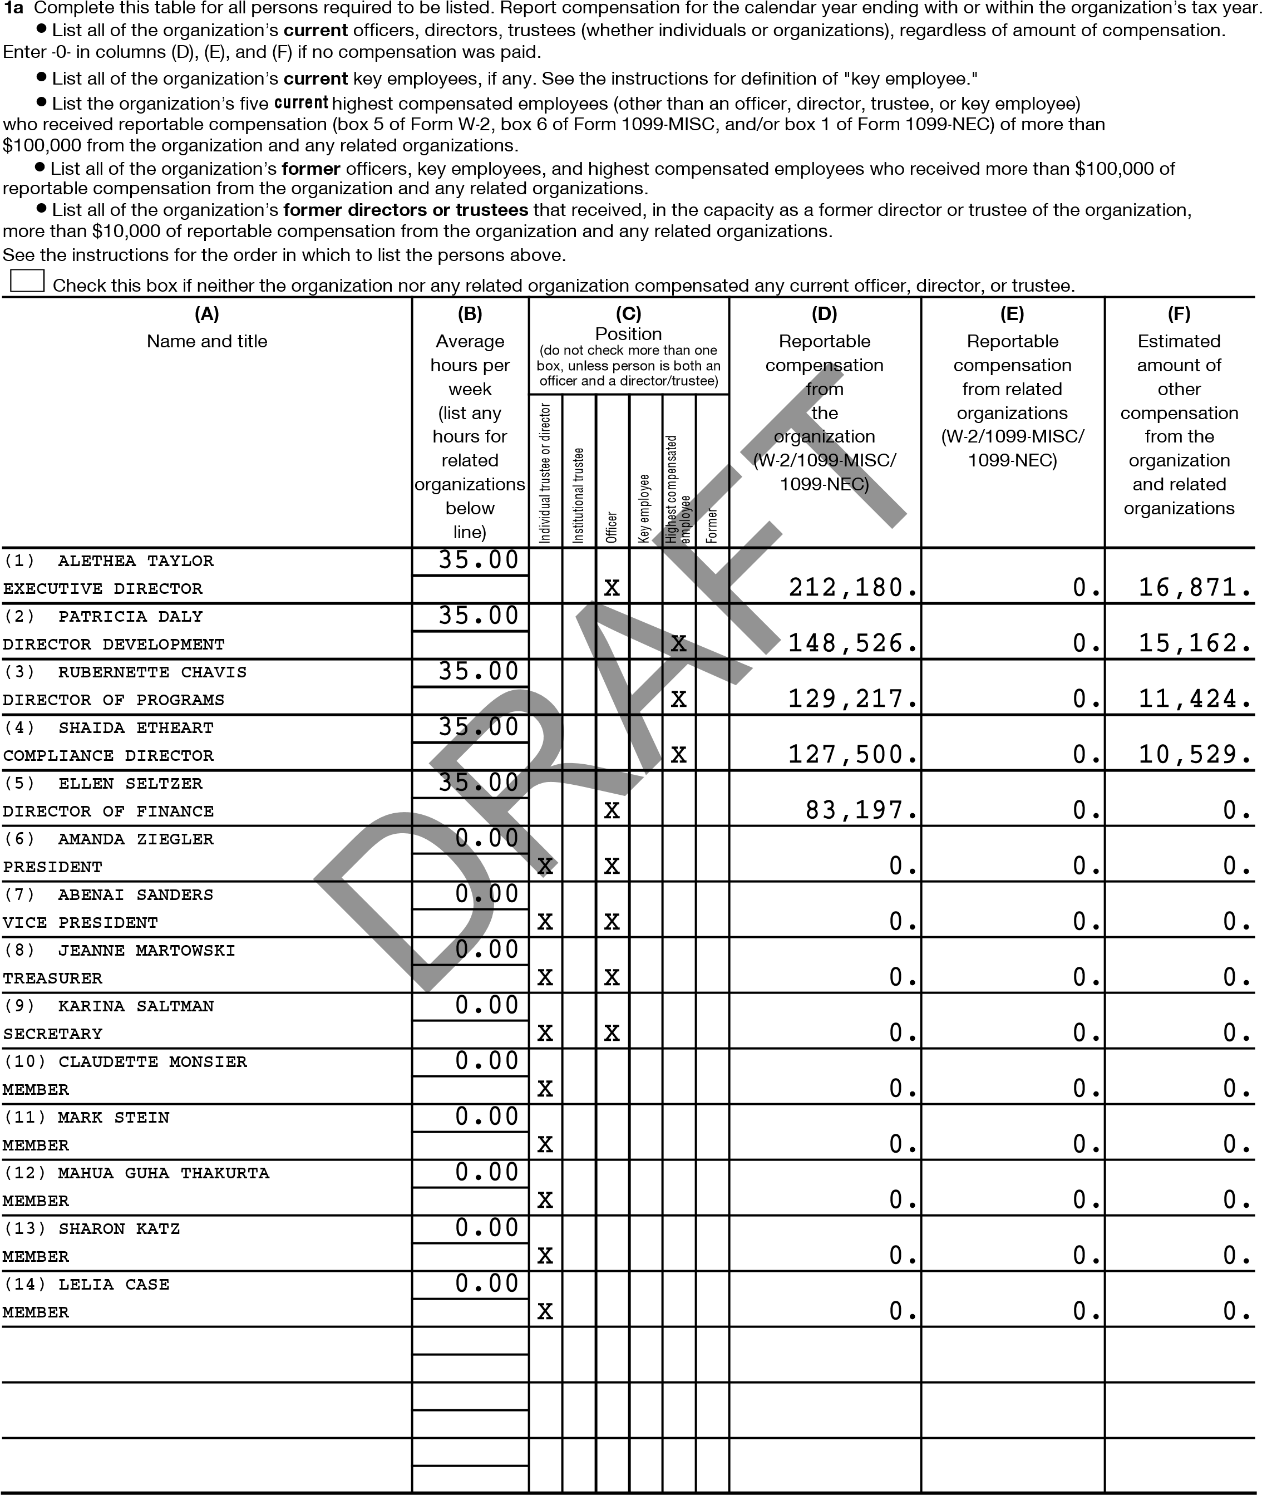
332007 12-21-23 (2023)
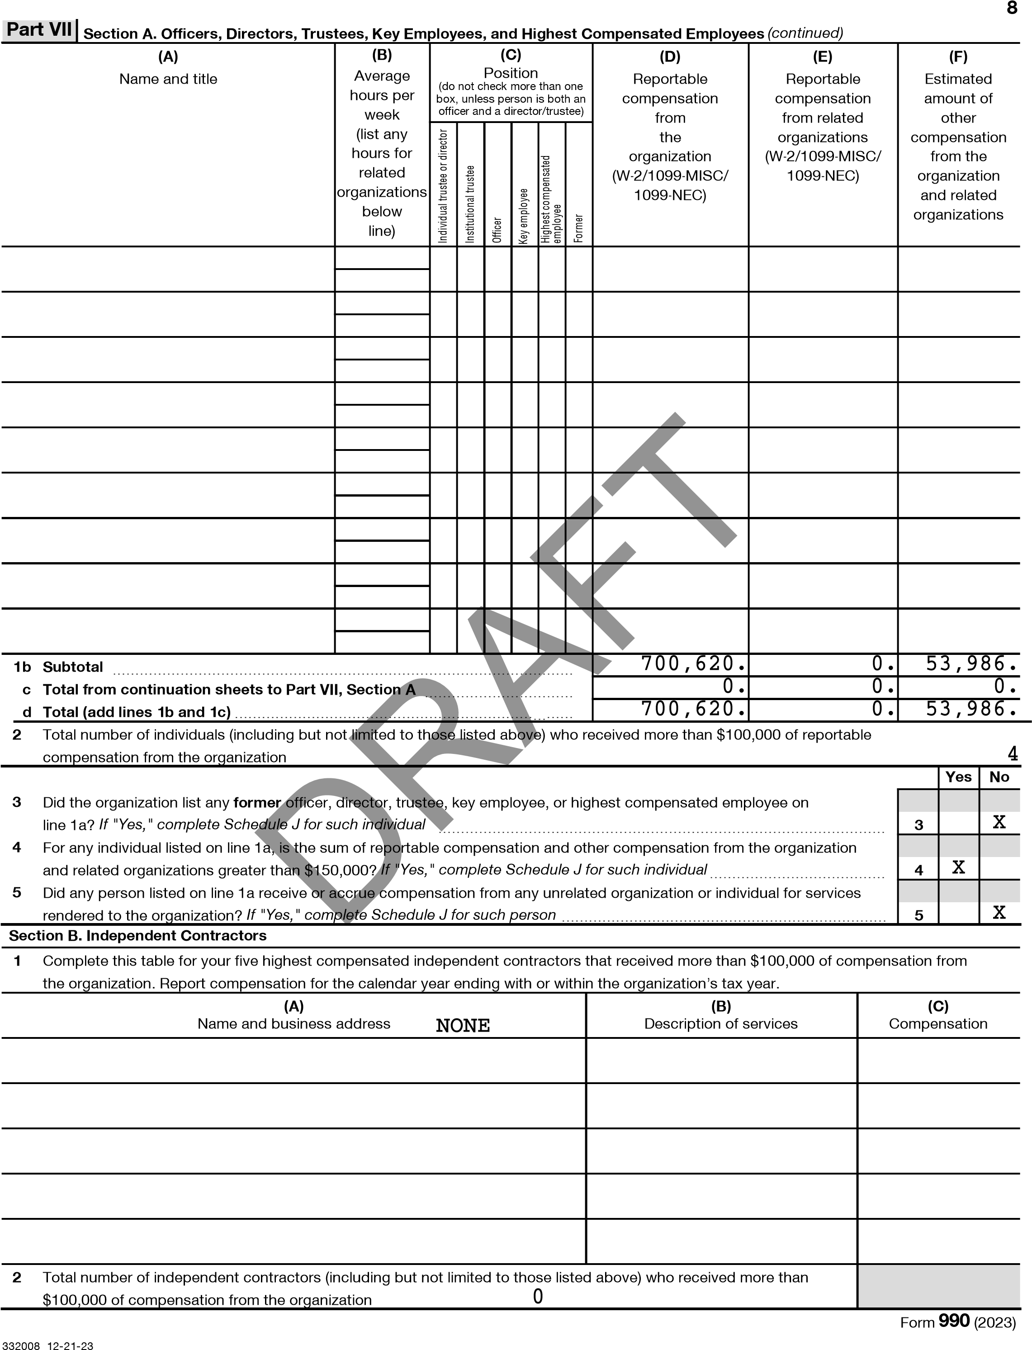
9
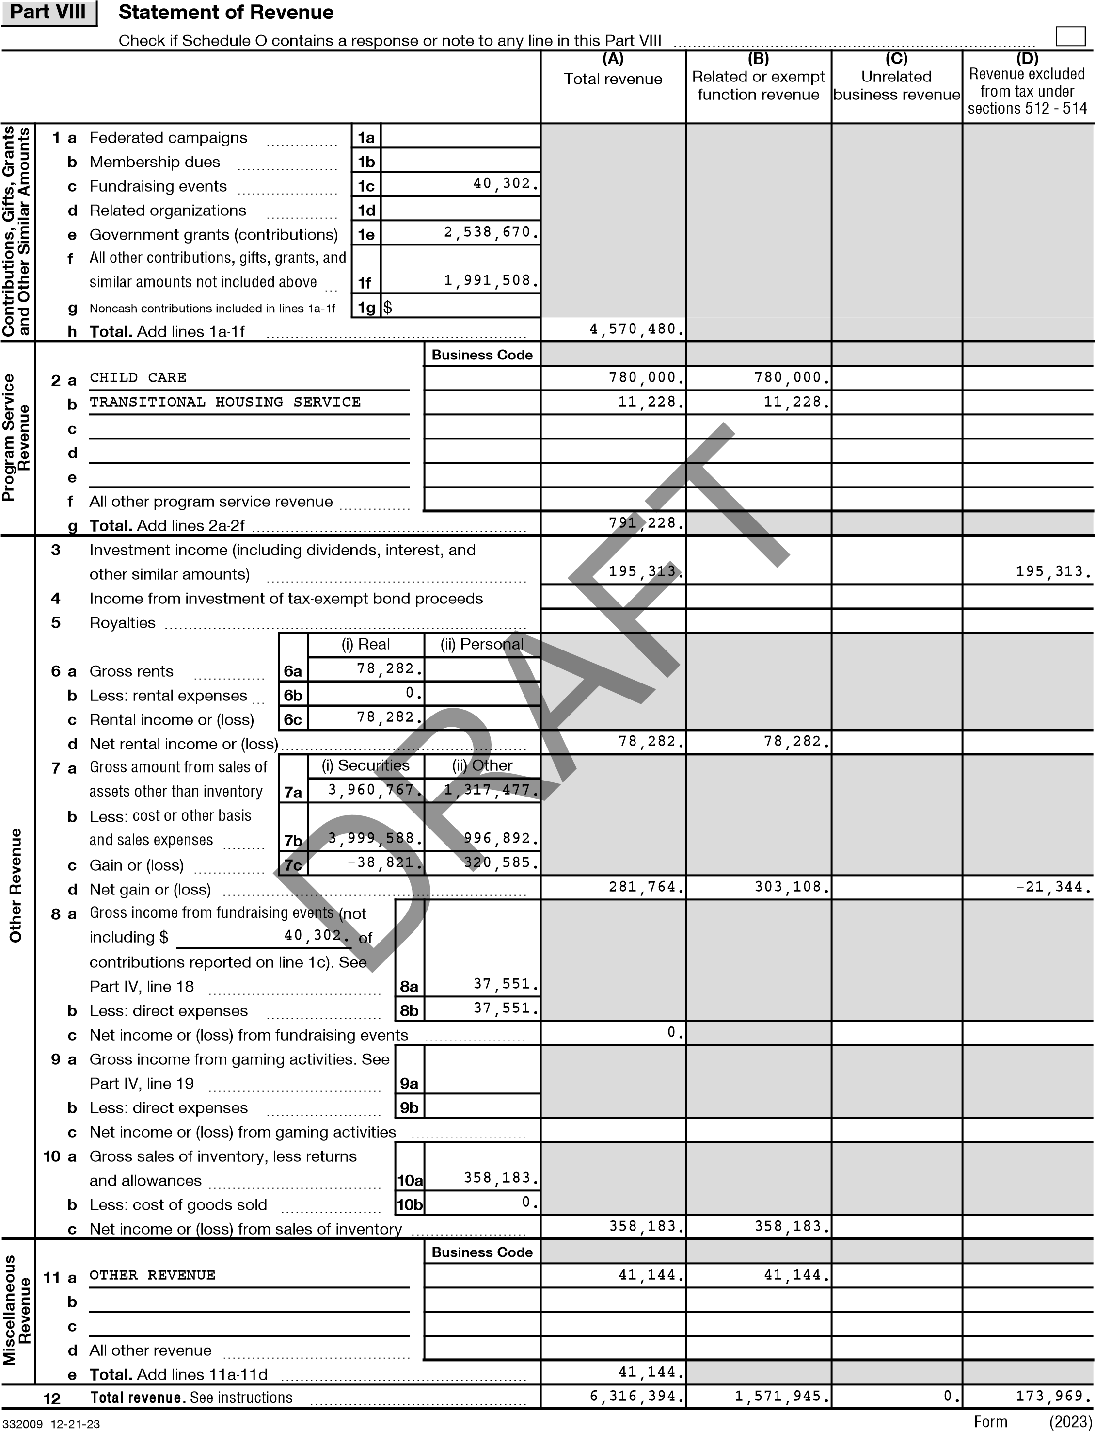

10
Part IX | Statement of Functional Expenses
Section 501(c)(3) and 501(c)(4) organizations must complete all columns. All other organizations must complete column (A).
Check if Schedule O contains a response or note to any line in this Part IX
Do not include amounts reported on lines 6b, 7b, 8b, 9b, and 10b of Part VIII. | (A) Total expenses | (B)  Program service expenses | (C) Management and general expenses | (D)  Fundraising expenses
- Grants and other assistance to domestic organizations and domestic governments. See Part IV, line 21 ~
- Grants and other assistance to domestic individuals. See Part IV, line 22 ~~~~~~~
- Grants and other assistance to foreign organizations, foreign governments, and foreign individuals. See Part IV, lines 15 and 16 ~~~ 4 Benefits paid to or for members ~~~~~~~
- Compensation of current officers, directors, trustees, and key employees ~~~~~~~~
- Compensation not included above to disqualified persons (as defined under section 4958(f)(1)) and persons described in section 4958(c)(3)(B) ~~~
- Other salaries and wages ~~~~~~~~~~
- Pension plan accruals and contributions (include section 401(k) and 403(b) employer contributions)
- Other employee benefits ~~~~~~~~~~ 10 Payroll taxes ~~~~~~~~~~~~~~~~
11 Fees for services (nonemployees):
a Management ~~~~~~~~~~~~~~~~ b Legal ~~~~~~~~~~~~~~~~~~~~ c Accounting ~~~~~~~~~~~~~~~~~ d Lobbying ~~~~~~~~~~~~~~~~~~
e Professional fundraising services. See Part IV, line 17 f Investment management fees~~~~~~~~
g Other. (If line 11g amount exceeds 10% of line 25, column (A), amount, list line 11g expenses on Sch O.)
- Advertising and promotion ~~~~~~~~~
- Office expenses~~~~~~~~~~~~~~~ 14 Information technology ~~~~~~~~~~~
D
15 Royalties ~~~~~~~~~~~~~~~~~~ 16 Occupancy ~~~~~~~~~~~~~~~~~
- Travel ~~~~~~~~~~~~~~~~~~~
- Payments of travel or entertainment expenses for any federal, state, or local public officials~
- Conferences, conventions, and meetings ~~
- Interest ~~~~~~~~~~~~~~~~~~
- Payments to affiliates ~~~~~~~~~~~~
- Depreciation, depletion, and amortization ~~
- Insurance ~~~~~~~~~~~~~~~~~
- Other expenses. Itemize expenses not covered above. (List miscellaneous expenses on line 24e. If line 24e amount exceeds 10% of line 25, column (A), amount, list line 24e expenses on Schedule O.)
a LEASE EXPENSE - OPERATI b CIENT ASSISTANCE c CLIENT FOOD
- REPAIRS AND MAINTENANCE
- All other expenses
25 Total functional expenses. Add lines 1 through 24e
 | 295,377. | 170,201. | 106,995. | 18,181.
 | 3,230,223. | 2,449,667. | 459,730. | 320,826.
 | 243,055. | 180,614. | 39,070. | 23,371.
 | 315,119. | 230,973. | 54,812. | 29,334.
 |  | FT
 | 60,656. |  | 60,656.
 | 25,800. |  | 25,800.
 | 495,585.  RA | 295,904. | 139,920. | 59,761.
 | 5,206. | 124. | 4,895. | 187.
 | 132,423. | 99,714. | 31,734. | 975.
 | 23,587. | 23,587.
 | 53,300. | 43,554. | 6,825. | 2,921.
 | 176,513. | 176,513.
 | 275,755. | 226,205. | 27,575. | 21,975.
 | 473,438. | 454,312. | 19,126.
 | 284,716. | 284,716.
 | 214,670. | 214,670.
 | 128,195. | 83,096. | 44,342. | 757.
 | 507,484. | 312,891. | 189,337. | 5,256.
 | 6,941,102. | 5,246,741. | 1,210,817. | 483,544.
26 Joint costs. Complete this line only if the organization reported in column (B) joint costs from a combined educational campaign and fundraising solicitation. Check here if following SOP 98-2 (ASC 958-720)
- 12-21-23 Form 990 (2023)
11
Part X | Balance Sheet
Check if Schedule O contains a response or note to any line in this Part X
 |  |  |  | (A) |  | (B)
 |  |  |  | Beginning of year |  | End of year
Assets | - Cash - non-interest-bearing  - Savings and temporary cash investments  - Pledges and grants receivable, net  - Accounts receivable, net ~~~~~~~~~~~~~~~~~~~~~~~~~~  - Loans and other receivables from any current or former officer, director, trustee, key employee, creator or founder, substantial contributor, or 35% controlled entity or family member of any of these persons  - Loans and other receivables from other disqualified persons (as defined under section 4958(f)(1)), and persons described in section 4958(c)(3)(B)  - Notes and loans receivable, net  - Inventories for sale or use  - Prepaid expenses and deferred charges  10a Land, buildings, and equipment: cost or other basis. Complete Part VI of Schedule D ~~~ b Less: accumulated depreciation ~~~~~~  - Investments - publicly traded securities  - Investments - other securities. See Part IV, line 11  - Investments - program-related. See Part IV, line 11  - Intangible assets ~~~~~~~~~~~~~~~~~~~~~~~~~~~~~~ 15 Other assets. See Part IV, line 11 ~~~~~~~~~~~~~~~~~~~~~~  16 Total assets. Add lines 1 through 15 (must equal line 33) | ~~~~~~~~~~~~~~~~~~~~~~~~~  ~~~~~~~~~~~~~~~~~~~~~~~~~~  10a | ~~~~~~~~~~~~~~~~~~  ~~~~~~~~~~~~~~~~~~~~~  ~~~~~~~~~  ~~  ~~~~~~~~~~~~~~~~~~~~~~~  ~~~~~~~~~~~~~~~~~~ 5,156,783. | 2,199,301. | 1 | 2,161,327.
 |  |  |  |  | 2
 |  |  |  | 443,465. | 3 | 316,863.
 |  |  |  | 3,633,215. | 4 | 2,780,791.
 |  |  |  |  | 5
 |  |  |  |  | 6
 |  |  |  |  | 7
 |  |  |  | 141,700. | 8 | 118,684.
 |  |  |  | 280,158. | 9 | 306,483.
Assets |  | 10b | 1,962,898. | 4,258,490. | 10c | 3,193,885.
Assets |  | ~~~~~~~~~~~~~~~~~~~  ~~~~~~~~~~~~~~  ~~~~~~~~~~~~~ |  |  | 11
Assets |  |  |  |  | 12
Assets |  |  |  |  | 13
Assets |  |  |  |  | 14
Assets |  |  |  | 10,121,849. | 15 | 11,854,054.
Assets |  |  |  | 21,078,178. | 16 | 20,732,087.
Liabilities | 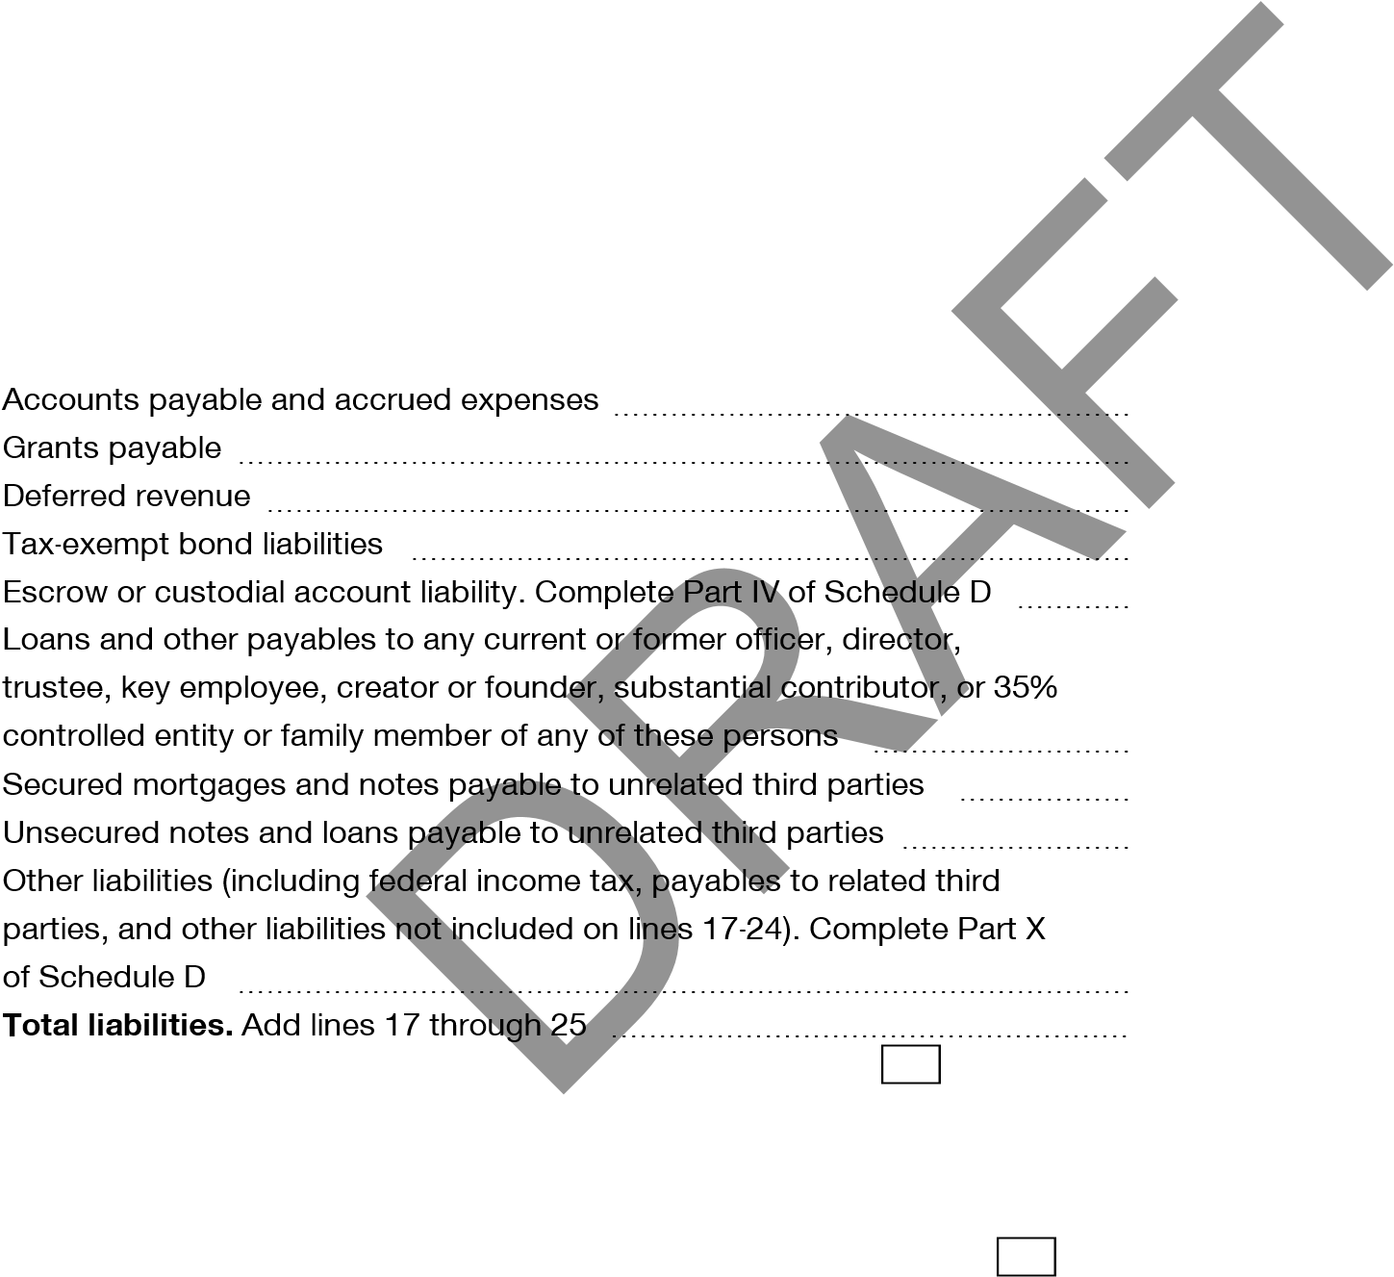  17  18  19  20  21  22  23  24  25  26 |  |  | 352,776. | 17 | 291,358.
Liabilities |  |  |  |  | 18
Liabilities |  |  |  |  | 19
Liabilities |  |  |  |  | 20
Liabilities |  |  |  |  | 21
Liabilities |  |  |  |  | 22
Liabilities |  |  |  |  | 23
Liabilities |  |  |  |  | 24
Liabilities |  |  |  | 2,279,073. | 25 | 1,840,763.
Liabilities |  |  |  | 2,631,849. | 26 | 2,132,121.
Net Assets or Fund Balances | Organizations that follow FASB ASC 958, check here X and complete lines 27, 28, 32, and 33.  - Net assets without donor restrictions ~~~~~~~~~~~~~~~~~~~~  - Net assets with donor restrictions ~~~~~~~~~~~~~~~~~~~~~~  Organizations that do not follow FASB ASC 958, check here and complete lines 29 through 33.  - Capital stock or trust principal, or current funds ~~~~~~~~~~~~~~~ 30 Paid-in or capital surplus, or land, building, or equipment fund ~~~~~~~~ 31 Retained earnings, endowment, accumulated income, or other funds ~~~~ 32 Total net assets or fund balances ~~~~~~~~~~~~~~~~~~~~~~  33 Total liabilities and net assets/fund balances
Net Assets or Fund Balances |  |  |  | 16,910,910. | 27 | 17,219,337.
Net Assets or Fund Balances |  |  |  | 1,535,419. | 28 | 1,380,629.
Net Assets or Fund Balances |  |  |  |  | 29
Net Assets or Fund Balances |  |  |  |  | 30
Net Assets or Fund Balances |  |  |  |  | 31
Net Assets or Fund Balances |  |  |  | 18,446,329. | 32 | 18,599,966.
Net Assets or Fund Balances |  |  |  | 21,078,178. | 33 | 20,732,087.
Form 990 (2023)
- 12-21-23
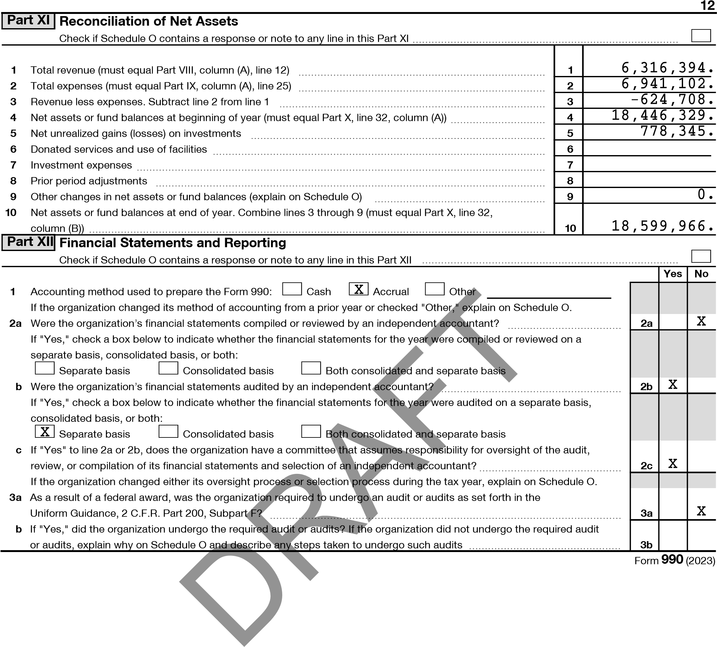
- 12-21-23

SCHEDULE A  (Form 990)  Department of the Treasury  Internal Revenue Service |  | Public Charity Status and Public Support  Complete if the organization is a section 501(c)(3) organization or a section 4947(a)(1) nonexempt charitable trust.  Attach to Form 990 or Form 990-EZ.  Go to www.irs.gov/Form990 for instructions and the latest information. |  | OMB No. 1545-0047
 |  |  |  | 2023
 |  |  |  | Open to Public Inspection
Name of the organization HOUR CHILDREN, INC. |  |  | Employer identification number **-***7412
Part I | Reason for Public Charity Status. (All organizations must complete this part.) See instructions.
The organization is not a private foundation because it is: (For lines 1 through 12, check only one box.)
- A church, convention of churches, or association of churches described in section 170(b)(1)(A)(i).
- A school described in section 170(b)(1)(A)(ii). (Attach Schedule E (Form 990).)
- A hospital or a cooperative hospital service organization described in section 170(b)(1)(A)(iii).
- A medical research organization operated in conjunction with a hospital described in section 170(b)(1)(A)(iii). Enter the hospital’s name, city, and state:
- An organization operated for the benefit of a college or university owned or operated by a governmental unit described in section 170(b)(1)(A)(iv). (Complete Part II.)
- A federal, state, or local government or governmental unit described in section 170(b)(1)(A)(v).
- X An organization that normally receives a substantial part of its support from a governmental unit or from the general public described in section 170(b)(1)(A)(vi). (Complete Part II.)
- A community trust described in section 170(b)(1)(A)(vi). (Complete Part II.)
- An agricultural research organization described in section 170(b)(1)(A)(ix) operated in conjunction with a land-grant college or university or a non-land-grant college of agriculture (see instructions). Enter the name, city, and state of the college or university:
- An organization that normally receives (1) more than 33 1/3% of its support from contributions, membership fees, and gross receipts from activities related to its exempt functions, subject to certain exceptions; and (2) no more than 33 1/3% of its support from gross investment income and unrelated business taxable income (less section 511 tax) from businesses acquired by the organization after June 30, 1975. See section 509(a)(2). (Complete Part III.)
- An organization organized and operated exclusively to test for public safety. See section 509(a)(4).

- An organization organized and operated exclusively for the benefit of, to perform the functions of, or to carry out the purposes of one or more publicly supported organizations described in section 509(a)(1) or section 509(a)(2). See section 509(a)(3). Check the box on lines 12a through 12d that describes the type of supporting organization and complete lines 12e, 12f, and 12g. a Type I. A supporting organization operated, supervised, or controlled by its supported organization(s), typically by giving the supported organization(s) the power to regularly appoint or elect a majority of the directors or trustees of the supporting organization. You must complete Part IV, Sections A and B.
- Type II. A supporting organization supervised or controlled in connection with its supported organization(s), by having control or management of the supporting organization vested in the same persons that control or manage the supported organization(s). You must complete Part IV, Sections A and C.
- Type III functionally integrated. A supporting organization operated in connection with, and functionally integrated with, its supported organization(s) (see instructions). You must complete Part IV, Sections A, D, and E.
- Type III non-functionally integrated. A supporting organization operated in connection with its supported organization(s) that is not functionally integrated. The organization generally must satisfy a distribution requirement and an attentiveness requirement (see instructions). You must complete Part IV, Sections A and D, and Part V.
- Check this box if the organization received a written determination from the IRS that it is a Type I, Type II, Type III functionally integrated, or Type III non-functionally integrated supporting organization.
- Enter the number of supported organizations ~~~~~~~~~~~~~~~~~~~~~~~~~~~~~~~~~~~~~ g Provide the following information about the supported organization(s).
(i) Name of supported (ii) EIN (iii) Type of organization (iv) Is the organization listed (v) Amount of monetary (vi) Amount of other organization (described on lines 1-10 in your governing document? support (see instructions) support (see instructions) above (see instructions)) Yes No
Total
LHA For Paperwork Reduction Act Notice, see the Instructions for Form 990 or 990-EZ. 332021 12-21-23
2
Part II | Support Schedule for Organizations Described in Sections 170(b)(1)(A)(iv) and 170(b)(1)(A)(vi)  (Complete only if you checked the box on line 5, 7, or 8 of Part I or if the organization failed to qualify under Part III. If the organization fails to qualify under the tests listed below, please complete Part III.)
Section A. Public Support
Calendar year (or fiscal year beginning in)  - Gifts, grants, contributions, and membership fees received. (Do not include any "unusual grants.") ~~  - Tax revenues levied for the organization’s benefit and either paid to  or expended on its behalf ~~~~  - The value of services or facilities furnished by a governmental unit to the organization without charge ~  - Total. Add lines 1 through 3 ~~~  - The portion of total contributions by each person (other than a governmental unit or publicly supported organization) included on line 1 that exceeds 2% of the amount shown on line 11,  column (f) ~~~~~~~~~~~~  - Public support. Subtract line 5 from line 4. | (a) 2019 | (b) 2020 | (c) 2021 | (d) 2022 | (e) 2023 | (f) Total
 | 4,746,685. | 5,810,826. | 5,831,484. | 5,472,880. | 4,570,480. | 26,432,355.
 | 4,746,685. | 5,810,826. | 5,831,484. | 5,472,880. | 4,570,480. | 26,432,355.
 |  |  |  |  |  | 2,774,643.
 |  |  |  |  |  | 23,657,712.
Calendar year (or fiscal year beginning in)  - Amounts from line 4 ~~~~~~~  - Gross income from interest, dividends, payments received on securities loans, rents, royalties, and income from similar sources ~  - Net income from unrelated business activities, whether or not the business is regularly carried on ~  - Other income. Do not include gain or loss from the sale of capital assets (Explain in Part VI.) ~~~~  - Total support. Add lines 7 through 10  - Gross receipts from related activities, etc. (see instructions) | (a) 2019 | (b) 2020 | (c) 2021 | (d) 2022 | (e) 2023 |  | (f) Total
 | 4,746,685. | 5,810,826. | 5,831,484. | 5,472,880. | 4,570,480. |  | 26,432,355.
 | 91,673. | 58,020. | 53,814. | 127,659. | 195,313. |  | 526,479.
 | 642. | 69,884. | 14,421. |  | 41,144. |  | 126,091.
 |  |  |  |  |  |  | 27,084,925.
 | ~~~~~~~~~~~~~~~~~~~~~~~ |  |  |  | 12 | 6,091,749.
Section C. Computation of Public Support Percentage
- Public support percentage for 2023 (line 6, column (f), divided by line 11, column (f)) ~~~~~~~~~~~  - Public support percentage from 2022 Schedule A, Part II, line 14 ~~~~~~~~~~~~~~~~~~~~~  16a 33 1/3% support test - 2023. If the organization did not check the box on line 13, and line 14 is 33 1/3% or more, check this box and  stop here. The organization qualifies as a publicly supported organization ~~~~~~~~~~~~~~~~~~~~~~~~~~~~~~~~ b 33 1/3% support test - 2022. If the organization did not check a box on line 13 or 16a, and line 15 is 33 1/3% or more, check this box  and stop here. The organization qualifies as a publicly supported organization ~~~~~~~~~~~~~~~~~~~~~~~~~~~~~~  17a 10% -facts-and-circumstances test - 2023. If the organization did not check a box on line 13, 16a, or 16b, and line 14 is 10% or more, and if the organization meets the facts-and-circumstances test, check this box and stop here.  meets the facts-and-circumstances test. The organization qualifies as a publicly supported organization  b 10% -facts-and-circumstances test - 2022. If the organization did not check a box on line 13, 16a, 16b, or 17a, and line 15 is 10% or more, and if the organization meets the facts-and-circumstances test, check this box and stop here.  organization meets the facts-and-circumstances test. The organization qualifies as a publicly supported organization ~~~~~~~~~~~  Private foundation. If the organization did not check a box on line 13, 16a, 16b, 17a, or 17b, check this box and see instructions | 14 | 87.35 | %
 | 15 | 89.89 | %
 | Explain in Part VI how the organization  ~~~~~~~~~~~~~~~~~  Explain in Part VI how the |  | X


Section B. Total Support
13 First 5 years. If the Form 990 is for the organization’s first, second, third, fourth, or fifth tax year as a section 501(c)(3) organization, check this box and stop here
Schedule A (Form 990) 2023
332022 12-21-23
3
Part III | Support Schedule for Organizations Described in Section 509(a)(2)  (Complete only if you checked the box on line 10 of Part I or if the organization failed to qualify under Part II. If the organization fails to qualify under the tests listed below, please complete Part II.)
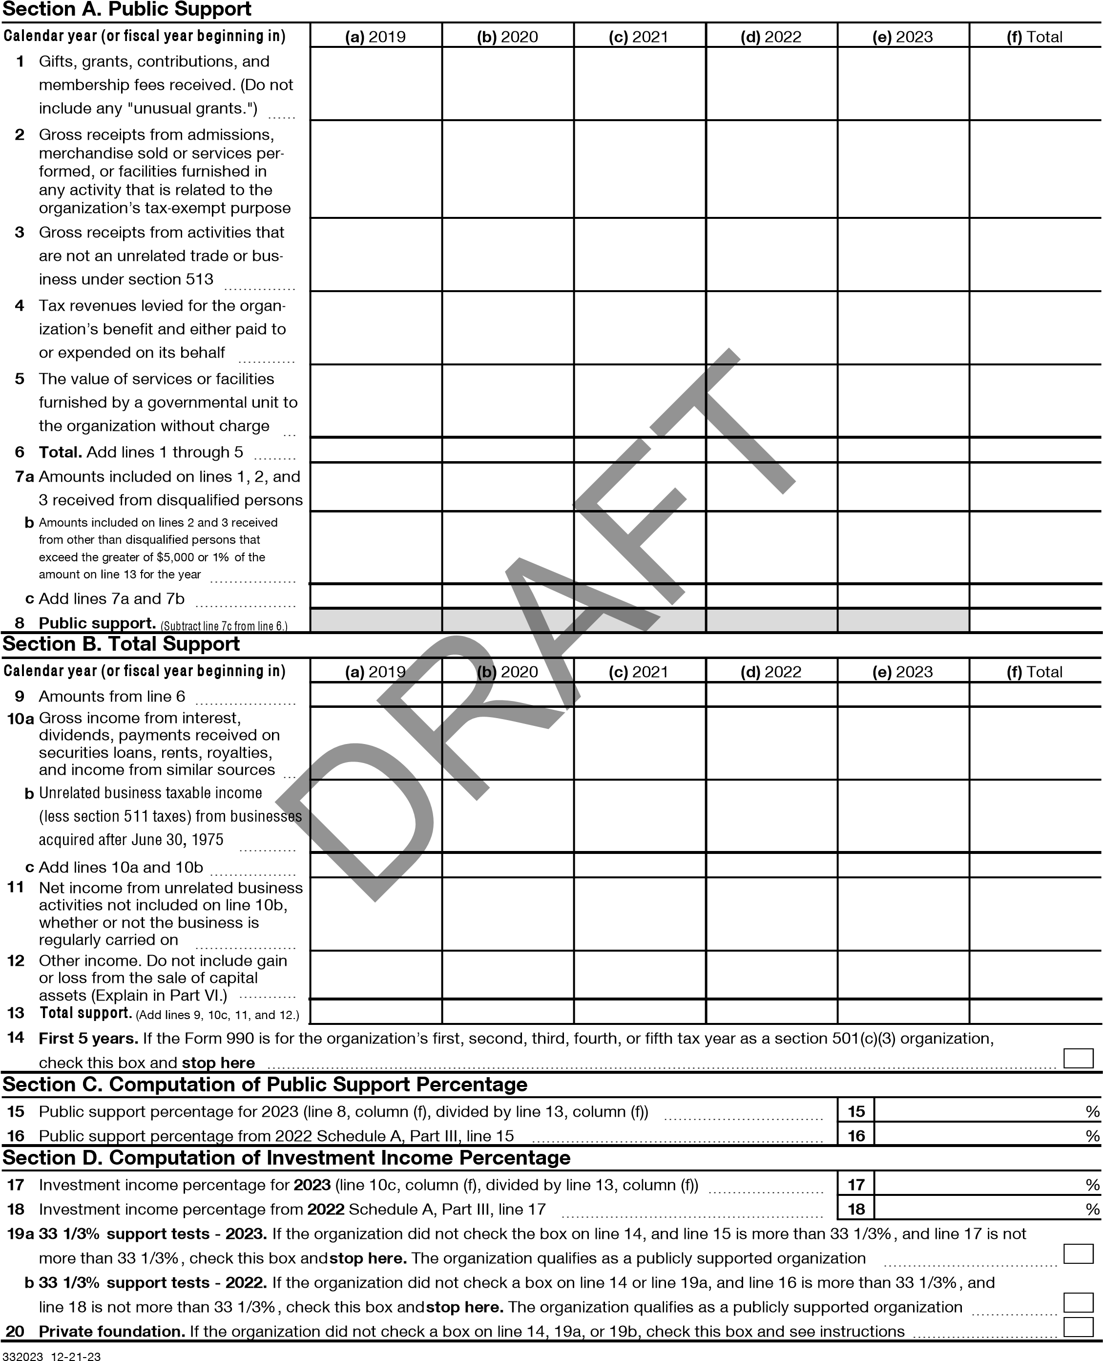

4
Part IV | Supporting Organizations  (Complete only if you checked a box on line 12 of Part I. If you checked box 12a, Part I, complete Sections A and B. If you checked box 12b, Part I, complete Sections A and C. If you checked box 12c, Part I, complete  Sections A, D, and E. If you checked box 12d, Part I, complete Sections A and D, and complete Part V.)

Section A. All Supporting Organizations
1  2  3a b  c  4a b  c 5a b  c  6  7  8  9a  b c 10a  b | Are all of the organization’s supported organizations listed by name in the organization’s governing documents? If "No," describe in Part VI how the supported organizations are designated. If designated by class or purpose, describe the designation. If historic and continuing relationship, explain.  Did the organization have any supported organization that does not have an IRS determination of status under section 509(a)(1) or (2)? If "Yes," explain in Part VI how the organization determined that the supported organization was described in section 509(a)(1) or (2).  Did the organization have a supported organization described in section 501(c)(4), (5), or (6)? If "Yes," answer lines 3b and 3c below.  Did the organization confirm that each supported organization qualified under section 501(c)(4), (5), or (6) and satisfied the public support tests under section 509(a)(2)? If "Yes," describe in Part VI when and how the organization made the determination.  Did the organization ensure that all support to such organizations was used exclusively for section 170(c)(2)(B) purposes? If "Yes," explain in Part VI what controls the organization put in place to ensure such use.  Was any supported organization not organized in the United States ("foreign supported organization")? If "Yes," and if you checked box 12a or 12b in Part I, answer lines 4b and 4c below.  Did the organization have ultimate control and discretion in deciding whether to make grants to the foreign supported organization? If "Yes," describe in Part VI how the organization had such control and discretion despite being controlled or supervised by or in connection with its supported organizations.  Did the organization support any foreign supported organization that does not have an IRS determination under sections 501(c)(3) and 509(a)(1) or (2)? If "Yes," explain in Part VI what controls the organization used to ensure that all support to the foreign supported organization was used exclusively for section 170(c)(2)(B) purposes.  Did the organization add, substitute, or remove any supported organizations during the tax year? If "Yes," answer lines 5b and 5c below (if applicable). Also, provide detail in Part VI, including (i) the names and EIN numbers of the supported organizations added, substituted, or removed; (ii) the reasons for each such action; (iii) the authority under the organization’s organizing document authorizing such action; and (iv) how the action was accomplished (such as by amendment to the organizing document).  DRAFT  Type I or Type II only. Was any added or substituted supported organization part of a class already designated in the organization’s organizing document?  Substitutions only. Was the substitution the result of an event beyond the organization’s control?  Did the organization provide support (whether in the form of grants or the provision of services or facilities) to anyone other than (i) its supported organizations, (ii) individuals that are part of the charitable class benefited by one or more of its supported organizations, or (iii) other supporting organizations that also support or benefit one or more of the filing organization’s supported organizations? If "Yes," provide detail in  Part VI.  Did the organization provide a grant, loan, compensation, or other similar payment to a substantial contributor (as defined in section 4958(c)(3)(C)), a family member of a substantial contributor, or a 35% controlled entity with regard to a substantial contributor? If "Yes," complete Part I of Schedule L (Form 990).  Did the organization make a loan to a disqualified person (as defined in section 4958) not described on line 7? If "Yes," complete Part I of Schedule L (Form 990).  Was the organization controlled directly or indirectly at any time during the tax year by one or more disqualified persons, as defined in section 4946 (other than foundation managers and organizations described in section 509(a)(1) or (2))? If "Yes," provide detail in Part VI.  Did one or more disqualified persons (as defined on line 9a) hold a controlling interest in any entity in which the supporting organization had an interest? If "Yes," provide detail in Part VI.  Did a disqualified person (as defined on line 9a) have an ownership interest in, or derive any personal benefit from, assets in which the supporting organization also had an interest? If "Yes," provide detail in Part VI. Was the organization subject to the excess business holdings rules of section 4943 because of section  4943(f) (regarding certain Type II supporting organizations, and all Type III non-functionally integrated supporting organizations)? If "Yes," answer line 10b below.  Did the organization have any excess business holdings in the tax year? (Use Schedule C, Form 4720, to determine whether the organization had excess business holdings.) |  | Yes | No
1  2  3a b  c  4a b  c 5a b  c  6  7  8  9a  b c 10a  b |  | 1
1  2  3a b  c  4a b  c 5a b  c  6  7  8  9a  b c 10a  b |  | 2
1  2  3a b  c  4a b  c 5a b  c  6  7  8  9a  b c 10a  b |  | 3a
1  2  3a b  c  4a b  c 5a b  c  6  7  8  9a  b c 10a  b |  | 3b
1  2  3a b  c  4a b  c 5a b  c  6  7  8  9a  b c 10a  b |  | 3c
1  2  3a b  c  4a b  c 5a b  c  6  7  8  9a  b c 10a  b |  | 4a
1  2  3a b  c  4a b  c 5a b  c  6  7  8  9a  b c 10a  b |  | 4b
1  2  3a b  c  4a b  c 5a b  c  6  7  8  9a  b c 10a  b |  | 4c
1  2  3a b  c  4a b  c 5a b  c  6  7  8  9a  b c 10a  b |  | 5a
1  2  3a b  c  4a b  c 5a b  c  6  7  8  9a  b c 10a  b |  | 5b
1  2  3a b  c  4a b  c 5a b  c  6  7  8  9a  b c 10a  b |  | 5c
1  2  3a b  c  4a b  c 5a b  c  6  7  8  9a  b c 10a  b |  | 6
1  2  3a b  c  4a b  c 5a b  c  6  7  8  9a  b c 10a  b |  | 7
1  2  3a b  c  4a b  c 5a b  c  6  7  8  9a  b c 10a  b |  | 8
1  2  3a b  c  4a b  c 5a b  c  6  7  8  9a  b c 10a  b |  | 9a
1  2  3a b  c  4a b  c 5a b  c  6  7  8  9a  b c 10a  b |  | 9b
1  2  3a b  c  4a b  c 5a b  c  6  7  8  9a  b c 10a  b |  | 9c
1  2  3a b  c  4a b  c 5a b  c  6  7  8  9a  b c 10a  b |  | 10a
1  2  3a b  c  4a b  c 5a b  c  6  7  8  9a  b c 10a  b |  | 10b
332024 12-21-23
5
Part IV | Supporting Organizations (continued)
11 Has the organization accepted a gift or contribution from any of the following persons? a A person who directly or indirectly controls, either alone or together with persons described on lines 11b and 11c below, the governing body of a supported organization? b A family member of a person described on line 11a above?  c A 35% controlled entity of a person described on line 11a or 11b above? If "Yes" to line 11a, 11b, or 11c, provide detail in Part VI. |  |  | Yes | No
 |  | 11a
 |  | 11b
 |  | 11c

Section B. Type I Supporting Organizations
1  2 | Did the governing body, members of the governing body, officers acting in their official capacity, or membership of one or more supported organizations have the power to regularly appoint or elect at least a majority of the organization’s officers, directors, or trustees at all times during the tax year? If "No," describe in Part VI how the supported organization(s) effectively operated, supervised, or controlled the organization’s activities. If the organization had more than one supported organization, describe how the powers to appoint and/or remove officers, directors, or trustees were allocated among the supported organizations and what conditions or restrictions, if any, applied to such powers during the tax year.  Did the organization operate for the benefit of any supported organization other than the supported organization(s) that operated, supervised, or controlled the supporting organization? If "Yes," explain in Part VI how providing such benefit carried out the purposes of the supported organization(s) that operated, supervised, or controlled the supporting organization. |  | Yes | No
1  2 |  | 1
1  2 |  | 2

Section C. Type II Supporting Organizations
1 | Were a majority of the organization’s directors or trustees during the tax year also a majority of the directors or trustees of each of the organization’s supported organization(s)? If "No," describe in Part VI how control or management of the supporting organization was vested in the same persons that controlled or managed the supported organization(s). |  | Yes | No
1 |  | 1

Section D. All Type III Supporting Organizations
 |  | Yes | No
- Did the organization provide to each of its supported organizations, by the last day of the fifth month of the organization’s tax year, (i) a written notice describing the type and amount of support provided during the prior tax year, (ii) a copy of the Form 990 that was most recently filed as of the date of notification, and (iii) copies of the organization’s governing documents in effect on the date of notification, to the extent not previously provided?
- Were any of the organization’s officers, directors, or trustees either (i) appointed or elected by the supported organization(s) or (ii) serving on the governing body of a supported organization? If "No," explain in Part VI how the organization maintained a close and continuous working relationship with the supported organization(s).
- By reason of the relationship described on line 2, above, did the organization’s supported organizations have a significant voice in the organization’s investment policies and in directing the use of the organization’s income or assets at all times during the tax year? If "Yes," describe in Part VI the role the organization’s supported organizations played in this regard.
 | 1
 | 2
 | 3

Section E. Type III Functionally Integrated Supporting Organizations

1 Check the box next to the method that the organization used to satisfy the Integral Part Test during the year (see instructions). a The organization satisfied the Activities Test. Complete line 2 below. b The organization is the parent of each of its supported organizations. Complete line 3 below. c The organization supported a governmental entity. Describe in Part VI how you supported a governmental entity (see instructions).
DRAFT
- a  b  - a b | Activities Test. Answer lines 2a and 2b below.  Did substantially all of the organization’s activities during the tax year directly further the exempt purposes of the supported organization(s) to which the organization was responsive? If "Yes," then in Part VI identify those supported organizations and explain how these activities directly furthered their exempt purposes, how the organization was responsive to those supported organizations, and how the organization determined that these activities constituted substantially all of its activities.  Did the activities described on line 2a, above, constitute activities that, but for the organization’s involvement, one or more of the organization’s supported organization(s) would have been engaged in? If "Yes," explain in Part VI the reasons for the organization’s position that its supported organization(s) would have engaged in these activities but for the organization’s involvement.  Parent of Supported Organizations. Answer lines 3a and 3b below.  Did the organization have the power to regularly appoint or elect a majority of the officers, directors, or trustees of each of the supported organizations? If "Yes" or "No" provide details in Part VI.  Did the organization exercise a substantial degree of direction over the policies, programs, and activities of each of its supported organizations? If "Yes," describe in Part VI the role played by the organization in this regard. |  | Yes | No
- a  b  - a b |  | 2a
- a  b  - a b |  | 2b
- a  b  - a b |  | 3a
- a  b  - a b |  | 3b
332025 12-21-23
6
Part V | Type III Non-Functionally Integrated 509(a)(3) Supporting Organizations
1 Check here if the organization satisfied the Integral Part Test as a qualifying trust on Nov. 20, 1970 (explain in Part VI See instructions.). All other Type III non-functionally integrated supporting organizations must complete Sections A through E.
Section A - Adjusted Net Income |  |  | (A) Prior Year | (B) Current Year (optional)
1 Net short-term capital gain |  | 1
2 Recoveries of prior-year distributions |  | 2
3 Other gross income (see instructions) |  | 3
4 Add lines 1 through 3. |  | 4
5 Depreciation and depletion |  | 5
6 Portion of operating expenses paid or incurred for production or collection of gross income or for management, conservation, or maintenance of property held for production of income (see instructions) |  | 6
7 Other expenses (see instructions) |  | 7
8 Adjusted Net Income (subtract lines 5, 6, and 7 from line 4) |  | 8
Section B - Minimum Asset Amount |  |  | (A) Prior Year | (B) Current Year (optional)
1 | Aggregate fair market value of all non-exempt-use assets (see instructions for short tax year or assets held for part of year):
a | Average monthly value of securities | 1a
b | Average monthly cash balances | 1b
c | Fair market value of other non-exempt-use assets | 1c
d | Total (add lines 1a, 1b, and 1c) | 1d
e | Discount claimed for blockage or other factors (explain in detail in Part VI):
2 | Acquisition indebtedness applicable to non-exempt-use assets | 2
3 | Subtract line 2 from line 1d. | 3
4 | Cash deemed held for exempt use. Enter 0.015 of line 3 (for greater amount, see instructions). | 4
5 |  | 5
6 | Multiply line 5 by 0.035. | 6
7 | Recoveries of prior-year distributions | 7
8 | Minimum Asset Amount (add line 7 to line 6) | 8
Section C - Distributable Amount |  |  |  | Current Year
1 Adjusted net income for prior year (from Section A, line 8, column A) |  | 1
2 Enter 0.85 of line 1. |  | 2
3 Minimum asset amount for prior year (from Section B, line 8, column A) |  | 3
4 Enter greater of line 2 or line 3. |  | 4
5 Income tax imposed in prior year |  | 5
6 Distributable Amount. Subtract line 5 from line 4, unless subject to emergency temporary reduction (see instructions). |  | 6
7 Check here if the current year is the organization’s first as a non-functionally integrated Type III supporting organization (see instructions).

Schedule A (Form 990) 2023
- 12-21-23

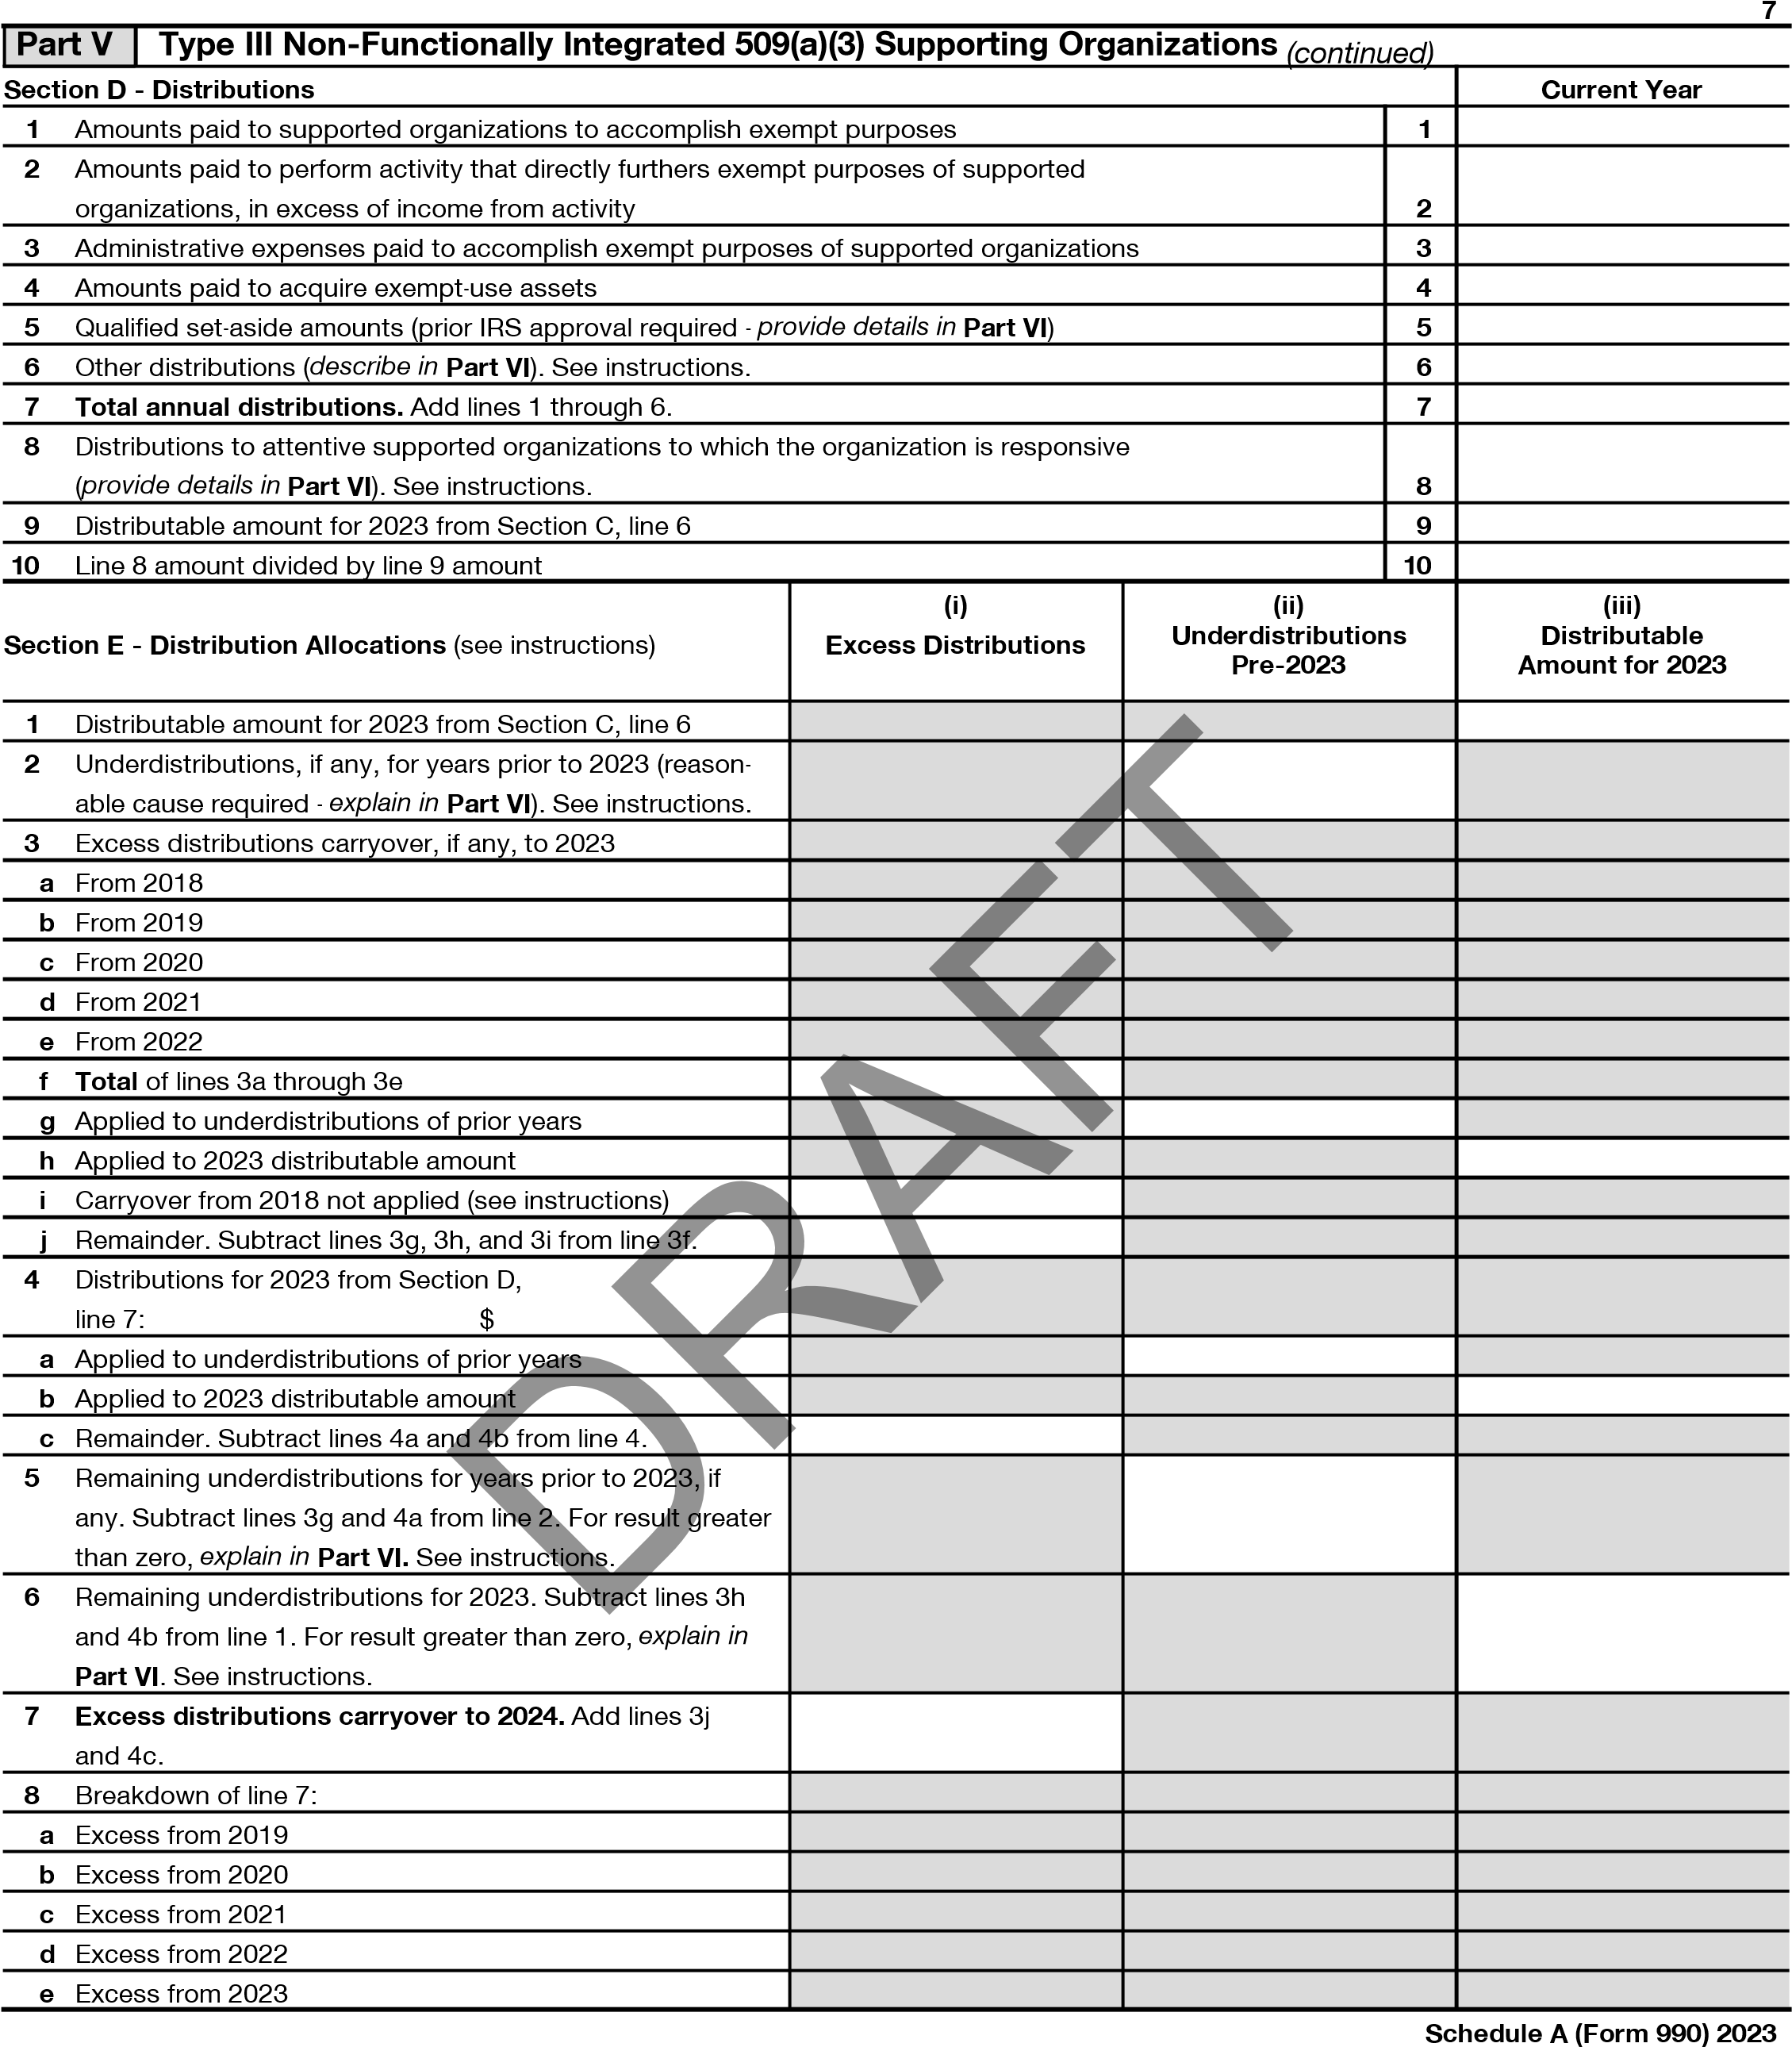
- 12-21-23
8
Part VI Supplemental Information. Provide the explanations required by Part II, line 10; Part II, line 17a or 17b; Part III, line 12;
Part IV, Section A, lines 1, 2, 3b, 3c, 4b, 4c, 5a, 6, 9a, 9b, 9c, 11a, 11b, and 11c; Part IV, Section B, lines 1 and 2; Part IV, Section C, line 1; Part IV, Section D, lines 2 and 3; Part IV, Section E, lines 1c, 2a, 2b, 3a, and 3b; Part V, line 1; Part V, Section B, line 1e; Part V, Section D, lines 5, 6, and 8; and Part V, Section E, lines 2, 5, and 6. Also complete this part for any additional information. (See instructions.)

SCHEDULE A, PART II, LINE 10, EXPLANATION FOR OTHER INCOME:
MISCELLANOUS INCOME
2019
AMOUNT: $
642.
2020
AMOUNT: $
69,884.
2021
AMOUNT: $
14,421.
2023
AMOUNT: $
41,144.
DRAFT

- 12-21-23 Schedule A (Form 990) 2023
Schedule B  (Form 990)  Department of the Treasury  Internal Revenue Service | Schedule of Contributors  Attach to Form 990, 990-EZ, or 990-PF.  Go to www.irs.gov/Form990 for the latest information. |  | OMB No. 1545-0047
 |  |  | 2023
Name of the organization |  | Employer identification number
HOUR CHILDREN, INC. |  | **-***7412
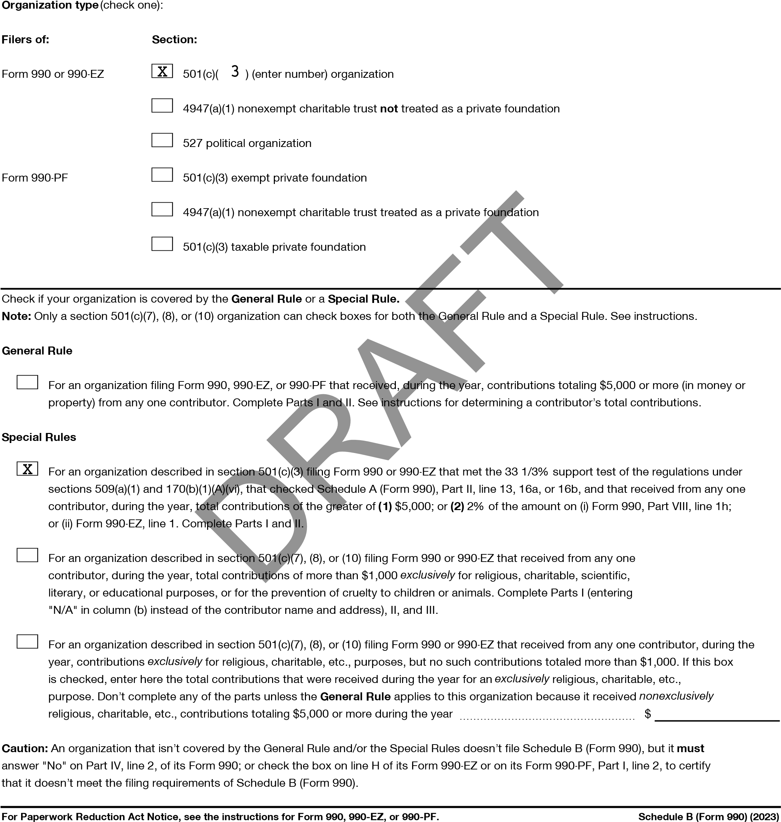
LHA 323451 12-26-23

2
Name of organization | Employer identification number
HOUR CHILDREN, INC. | **-***7412
Part I
Contributors (see instructions). Use duplicate copies of Part I if additional space is needed.
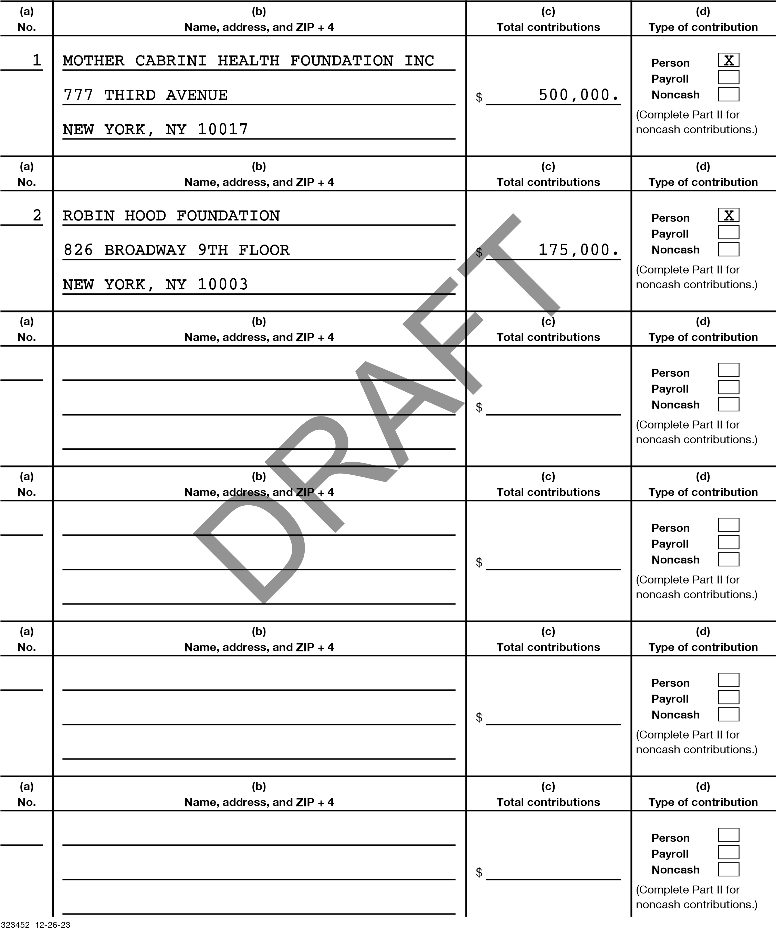
Page 3
Name of organization | Employer identification number
HOUR CHILDREN, INC. | **-***7412
Part II Noncash Property (see instructions). Use duplicate copies of Part II if additional space is needed.
323453 12-26-23
(
a
)
No.
from
Part I
(
c
)
FMV (or estimate)
(
b
)
Description of noncash property given
(
d
)
Date received
(
a
)
No.
from
Part I
c
)
(
FMV (or estimate)
b
)
(
Description of noncash property given
d
)
(
Date received
(
a
)
No.
from
Part I
(
c
)
FMV (or estimate)
(
)
b
Description of noncash property given
(
d
)
Date received
(
a
)
No.
from
Part I
c
)
(
FMV (or estimate)
(
b
)
Description of noncash property given
d
(
)
Date received
)
(
a
No.
from
Part I
c
)
(
FMV (or estimate)
b
(
)
Description of noncash property given
)
d
(
Date received
(
)
a
No.
from
Part I
(
c
)
FMV (or estimate)
(
b
)
Description of noncash property given
)
(
d
Date received
)
(
See instructions.
$
)
See instructions.
(
$
)
(
See instructions.
$
)
See instructions.
(
$
(
See instructions.
)
$
(
See instructions.
)
$
DRAFT
4
Name of organization  HOUR CHILDREN, INC. |  | Employer identification number  **-***7412
Part III | Exclusively religious, charitable, etc., contributions to organizations described in section 501(c)(7), (8), or (10) that total more than $1,000 for the year
from any one contributor. Complete columns (a) through (e) and the following line entry. For organizations
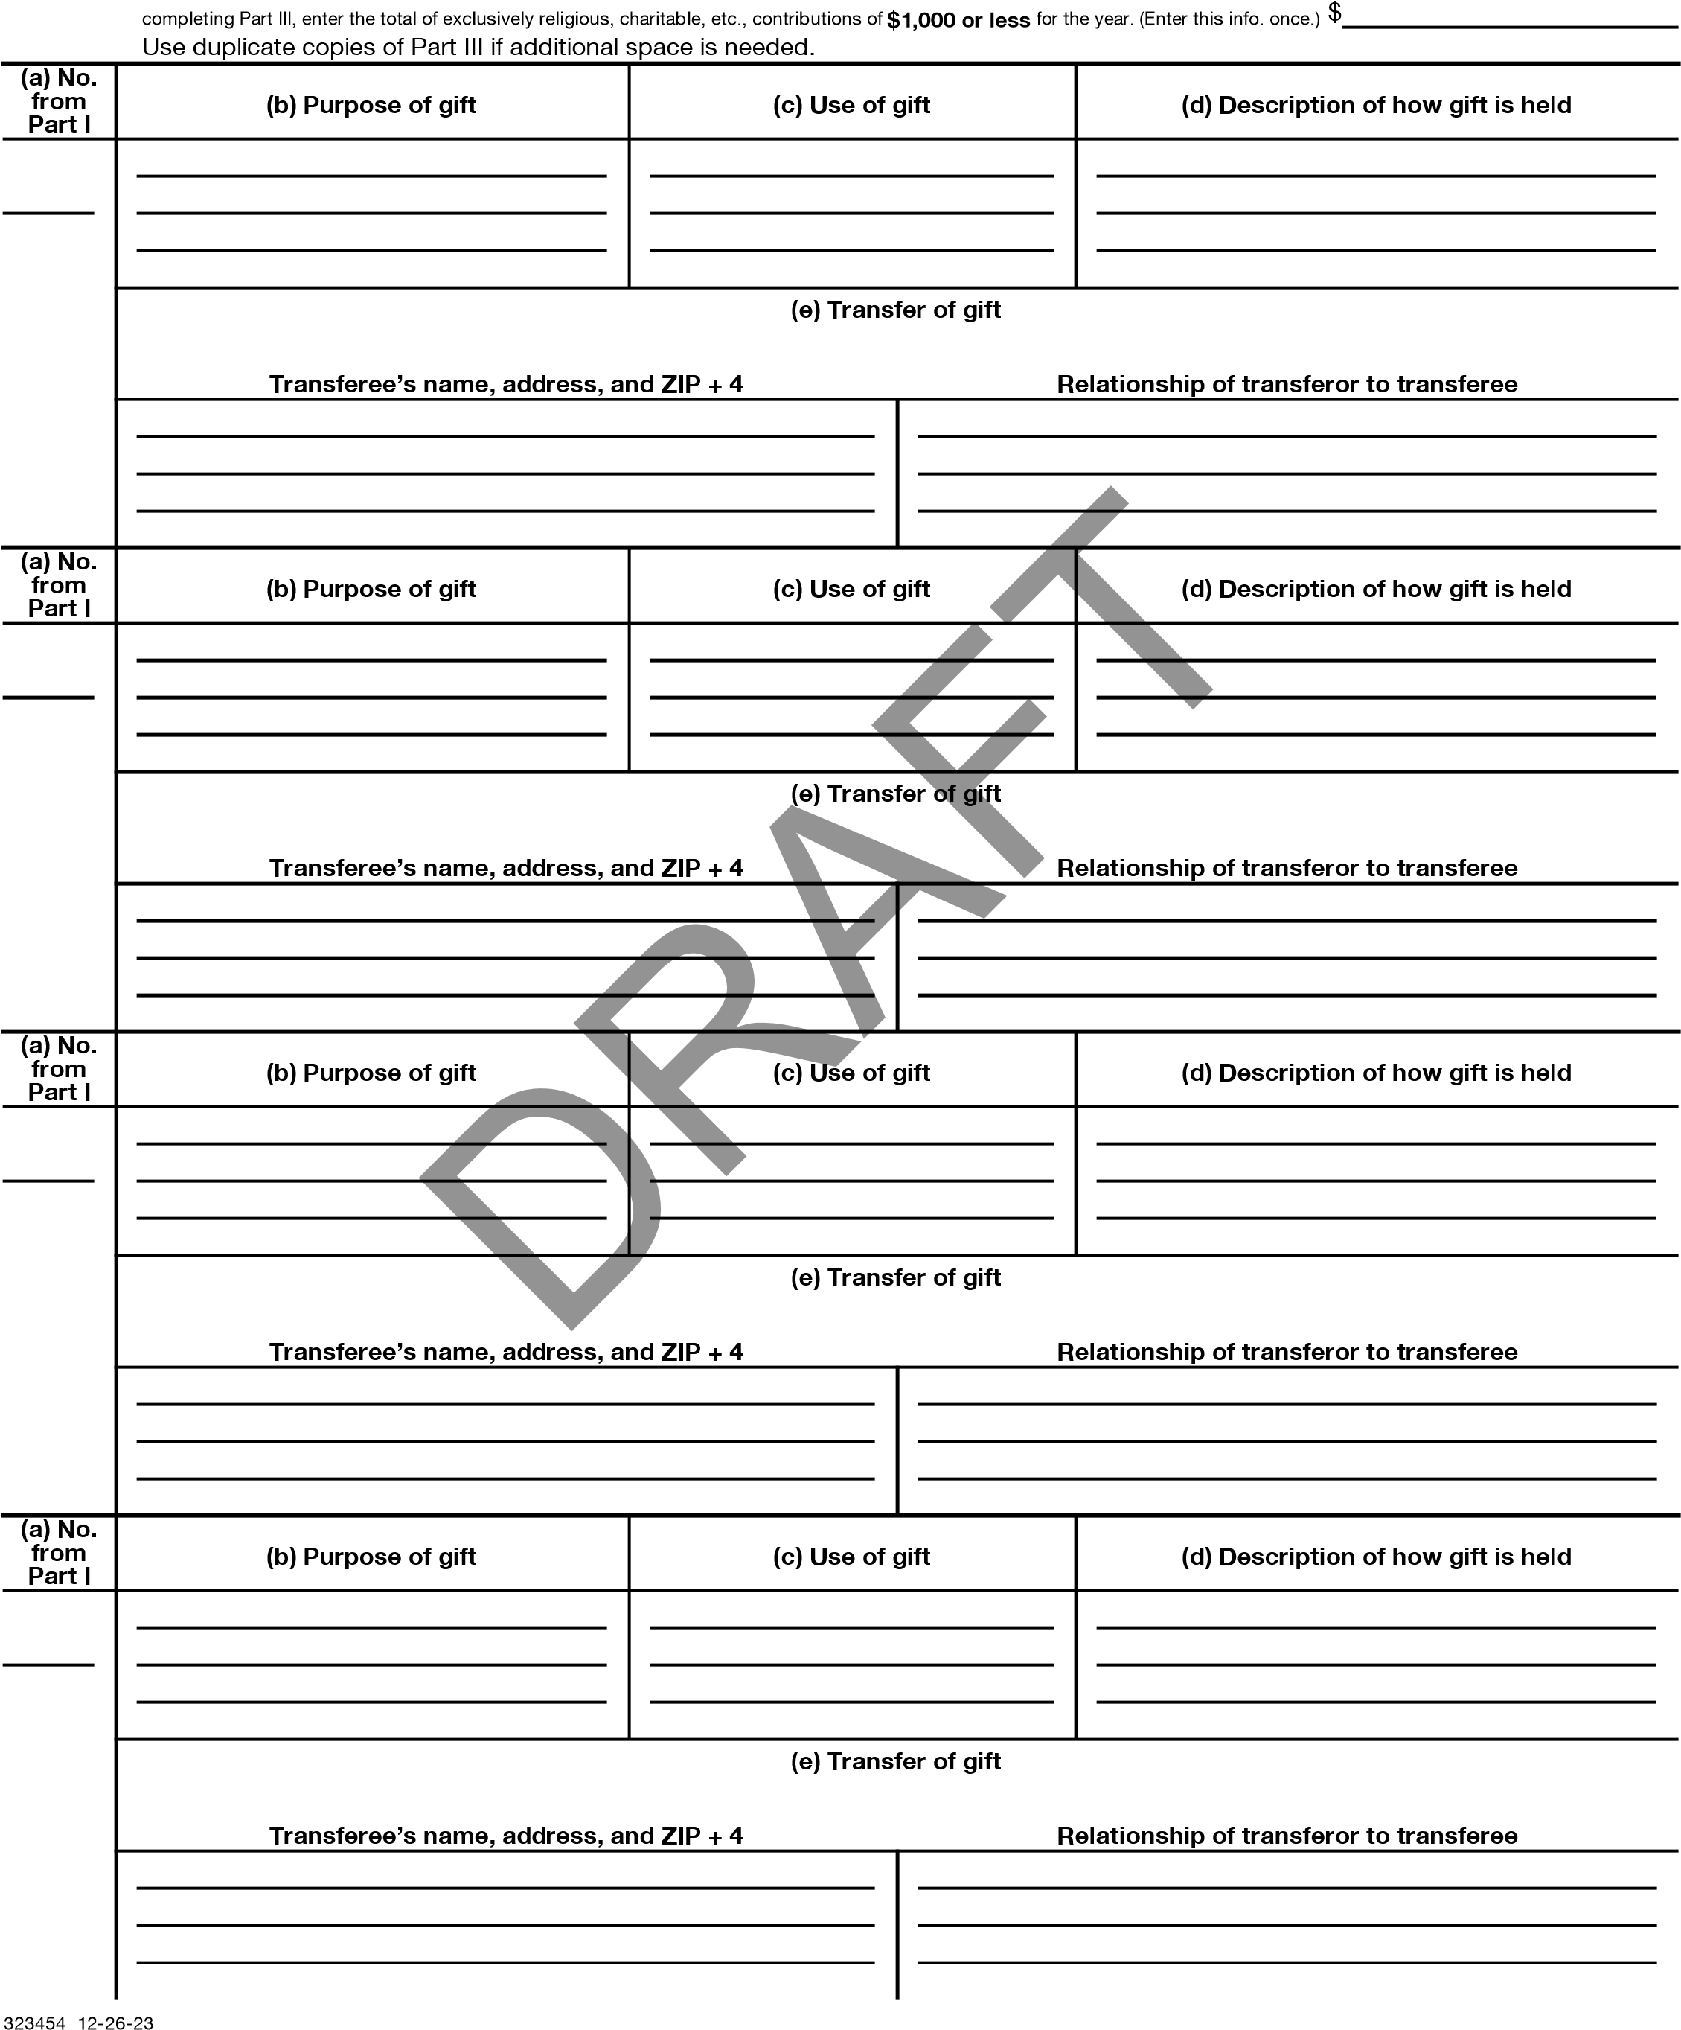

SCHEDULE D  (Form 990)  Department of the Treasury  Internal Revenue Service |  | Supplemental Financial Statements  Complete if the organization answered "Yes" on Form 990, Part IV, line 6, 7, 8, 9, 10, 11a, 11b, 11c, 11d, 11e, 11f, 12a, or 12b.  Attach to Form 990.  Go to www.irs.gov/Form990 for instructions and the latest information. |  | OMB No. 1545-0047
 |  |  |  | 2023
 |  |  |  | Open to Public Inspection
Name of the organization HOUR CHILDREN, INC. |  |  | Employer identification number **-***7412
Part I | Organizations Maintaining Donor Advised Funds or Other Similar Funds or Accounts. Complete if the
organization answered "Yes" on Form 990, Part IV, line 6.
1  2  3  4 | Total number at end of year ~~~~~~~~~~~~~~~  Aggregate value of contributions to (during year) ~~~~ Aggregate value of grants from (during year) ~~~~~~  Aggregate value at end of year ~~~~~~~~~~~~~ | (a) Donor advised funds | (b) Funds and other accounts
5 Did the organization inform all donors and donor advisors in writing that the assets held in donor advised funds
are the organization’s property, subject to the organization’s exclusive legal control?~~~~~~~~~~~~~~~~~~  6 Did the organization inform all grantees, donors, and donor advisors in writing that grant funds can be used only for charitable purposes and not for the benefit of the donor or donor advisor, or for any other purpose conferring impermissible private benefit? |  | Yes  Yes | No  No
Part II | Conservation Easements. Complete if the organization answered "Yes" on Form 990, Part IV, line 7.
- Purpose(s) of conservation easements held by the organization (check all that apply).
Preservation of land for public use (for example, recreation or education) Preservation of a historically important land area
Protection of natural habitat Preservation of a certified historic structure
Preservation of open space
Held at the End of the Tax Year
2a
2b
2c
2d
- Complete lines 2a through 2d if the organization held a qualified conservation contribution in the form of a conservation easement on the last day of the tax year.

a Total number of conservation easements ~~~~~~~~~~~~~~~~~~~~~~~~~~~~~~~~ b Total acreage restricted by conservation easements ~~~~~~~~~~~~~~~~~~~~~~~~~~ c Number of conservation easements on a certified historic structure included on line 2a ~~~~~~~~~ d Number of conservation easements included on line 2c acquired after July 25, 2006, and not on a historic structure listed in the National Register~~~~~~~~~~~~~~~~~~~~~~~~~~~
- Number of conservation easements modified, transferred, released, extinguished, or terminated by the organization during the tax year
- Number of states where property subject to conservation easement is located
- Does the organization have a written policy regarding the periodic monitoring, inspection, handling of
violations, and enforcement of the conservation easements it holds? ~~~~~~~~~~~~~~~~~~~~~~~~~ Yes No
- Staff and volunteer hours devoted to monitoring, inspecting, handling of violations, and enforcing conservation easements during the year
- Amount of expenses incurred in monitoring, inspecting, handling of violations, and enforcing conservation easements during the year
- Does each conservation easement reported on line 2d above satisfy the requirements of section 170(h)(4)(B)(i)
and section 170(h)(4)(B)(ii)? ~~~~~~~~~~~~~~~~~~~~~~~~~~~~~~~~~~~~~~~~~~~~~~ Yes No
- In Part XIII, describe how the organization reports conservation easements in its revenue and expense statement and balance sheet, and include, if applicable, the text of the footnote to the organization’s financial statements that describes the organization’s accounting for conservation easements.
Part III | Organizations Maintaining Collections of Art, Historical Treasures, or Other Similar Assets.  Complete if the organization answered "Yes" on Form 990, Part IV, line 8.
1a If the organization elected, as permitted under FASB ASC 958, not to report in its revenue statement and balance sheet works of art, historical treasures, or other similar assets held for public exhibition, education, or research in furtherance of public service, provide in Part XIII the text of the footnote to its financial statements that describes these items.
b If the organization elected, as permitted under FASB ASC 958, to report in its revenue statement and balance sheet works of art, historical treasures, or other similar assets held for public exhibition, education, or research in furtherance of public service, provide the following amounts relating to these items.
- Revenue included on Form 990, Part VIII, line 1 ~~~~~~~~~~~~~~~~~~~~~~~~~~~~~~ $
- Assets included in Form 990, Part X ~~~~~~~~~~~~~~~~~~~~~~~~~~~~~~~~~~~ $
2 If the organization received or held works of art, historical treasures, or other similar assets for financial gain, provide the following amounts required to be reported under FASB ASC 958 relating to these items:
a Revenue included on Form 990, Part VIII, line 1 ~~~~~~~~~~~~~~~~~~~~~~~~~~~~~~~~
LHA For Paperwork Reduction Act Notice, see the Instructions for Form 990. Schedule D (Form 990) 2023
332051 09-28-23
2
Part III | Organizations Maintaining Collections of Art, Historical Treasures, or Other Similar Assets (continued)
3 Using the organization’s acquisition, accession, and other records, check any of the following that make significant use of its collection items (check all that apply).
- Public exhibition d Loan or exchange program
- Scholarly research e Other c Preservation for future generations
- Provide a description of the organization’s collections and explain how they further the organization’s exempt purpose in Part XIII.
- During the year, did the organization solicit or receive donations of art, historical treasures, or other similar assets
to be sold to raise funds rather than to be maintained as part of the organization’s collection? Yes No
Part IV | Escrow and Custodial Arrangements Complete if the organization answered "Yes" on Form 990, Part IV, line 9, or reported an amount on Form 990, Part X, line 21.
1a Is the organization an agent, trustee, custodian, or other intermediary for contributions or other assets not included
on Form 990, Part X? ~~~~~~~~~~~~~~~~~~~~~~~~~~~~~~~~~~~~~~~~~~~~~~~~~ Yes No b If "Yes," explain the arrangement in Part XIII and complete the following table:
Amount
1c
1d
1e
1f
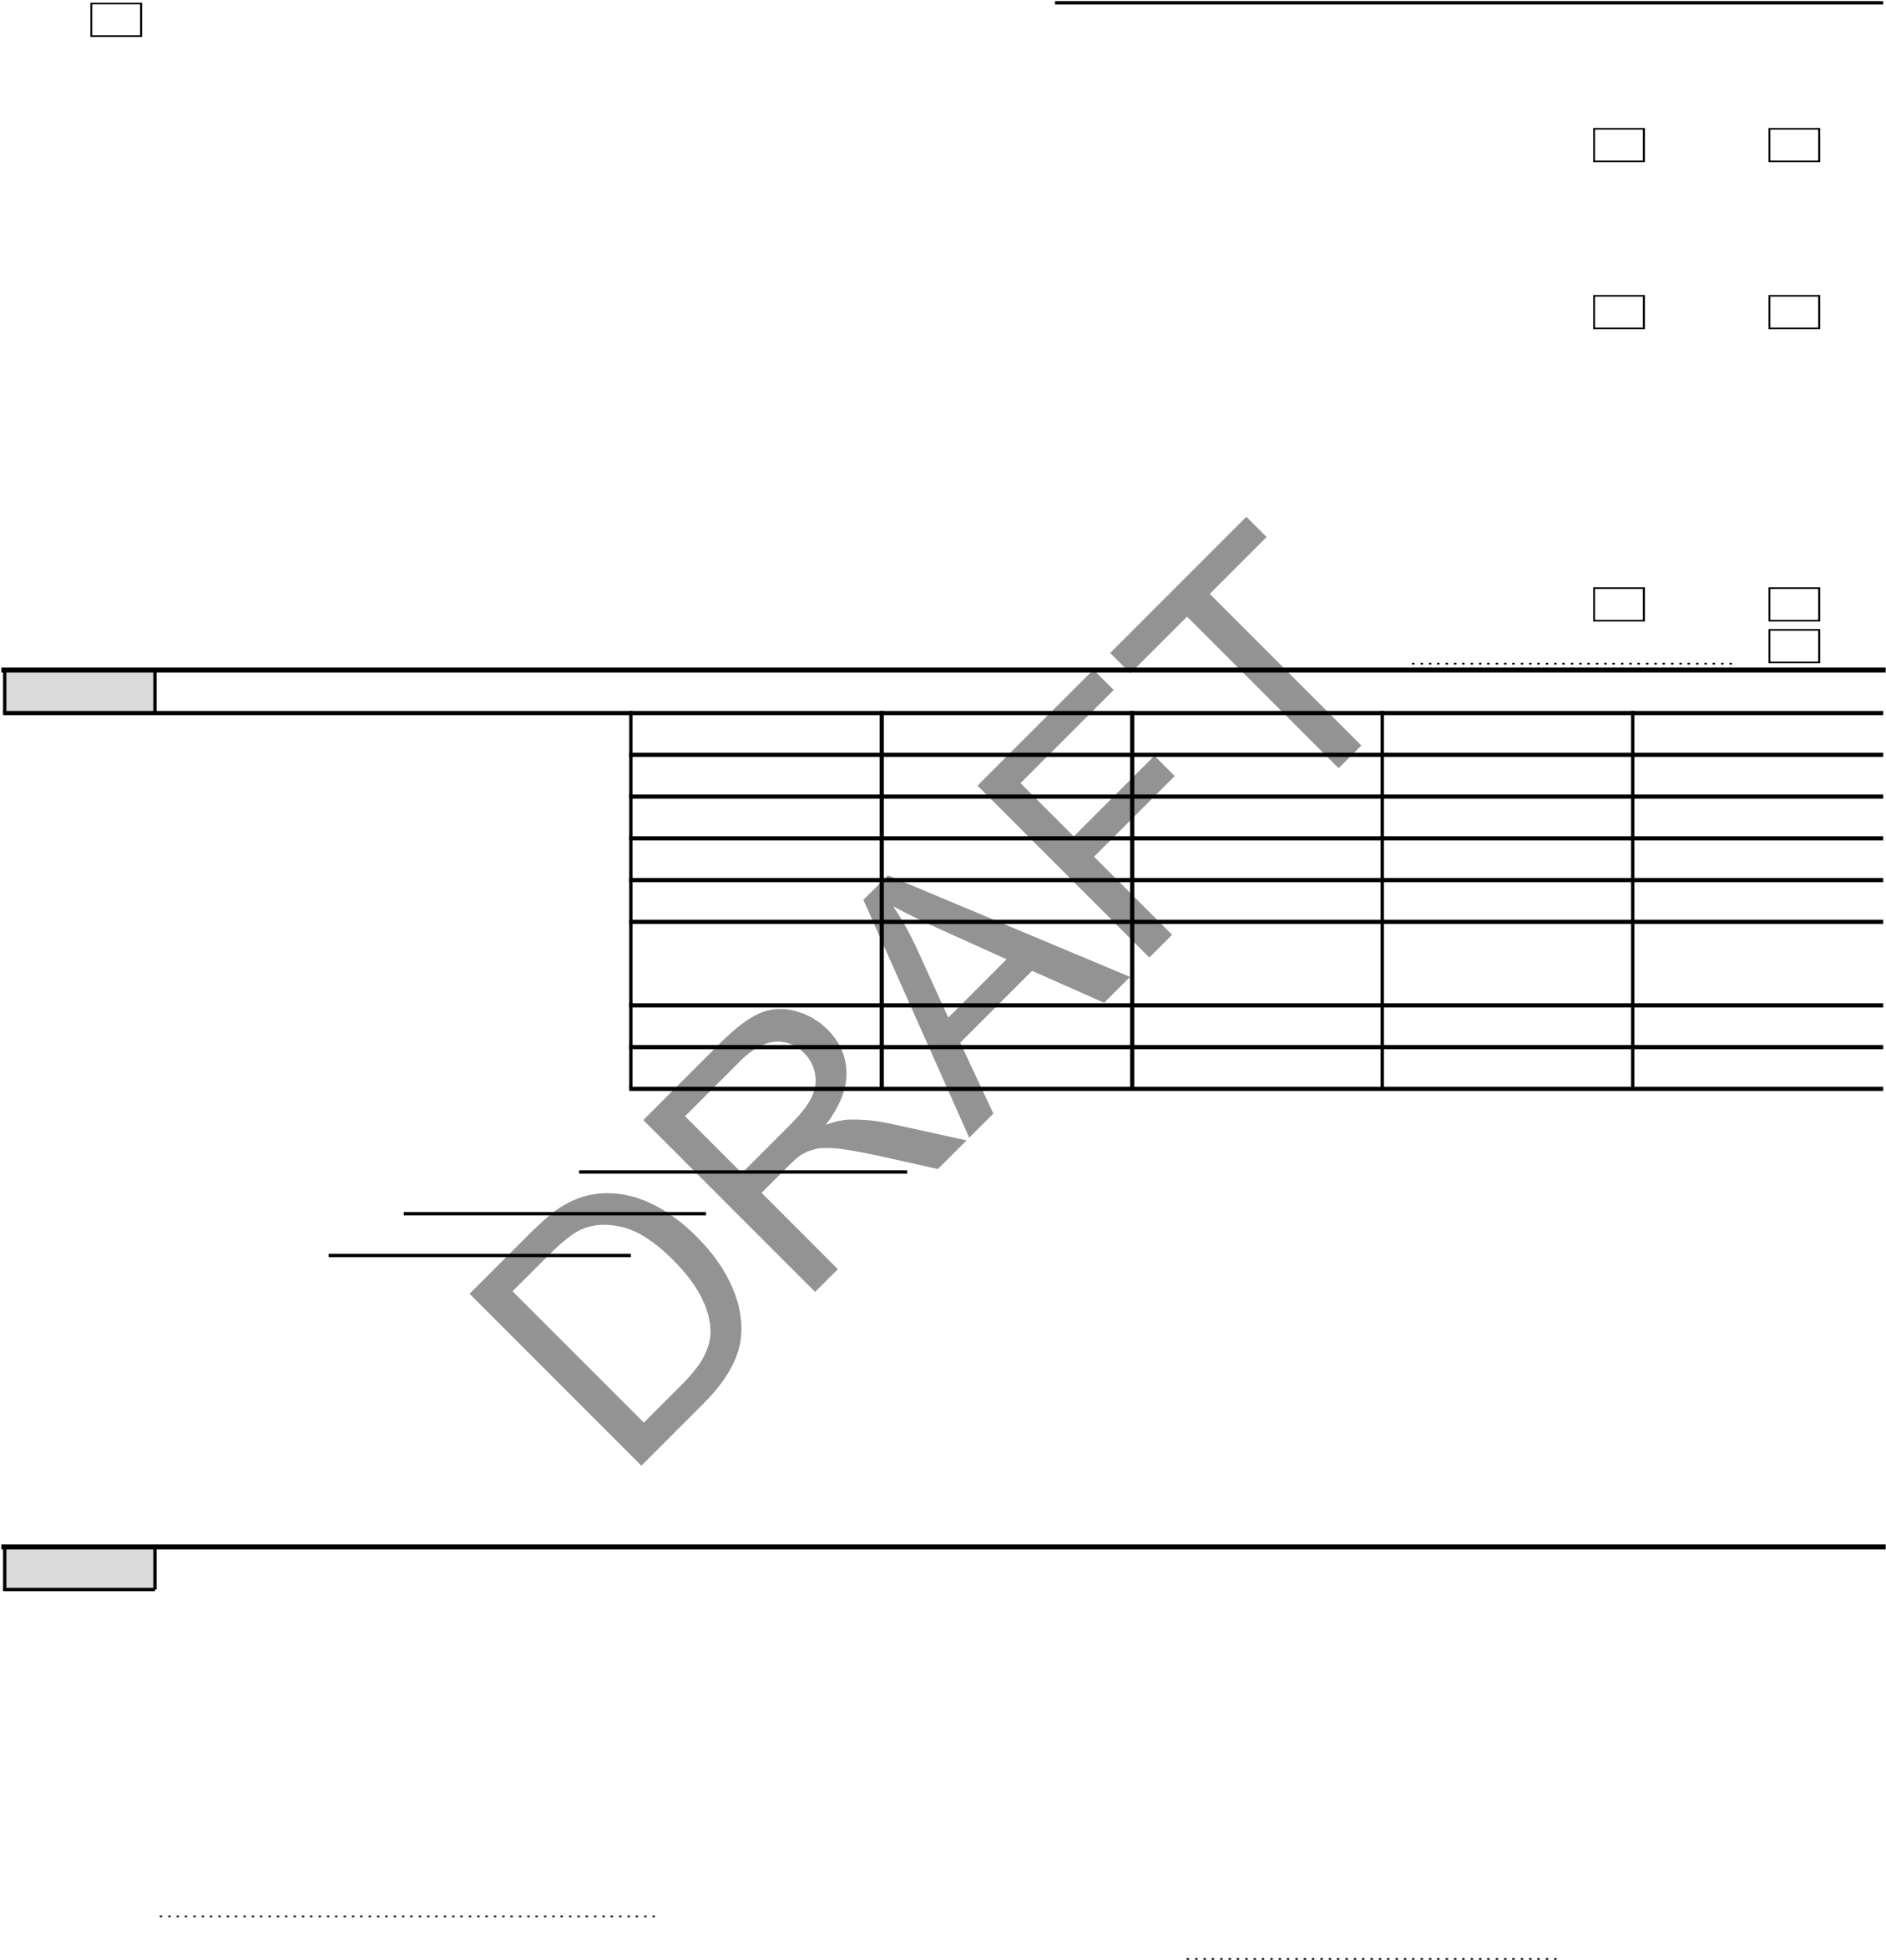
c Beginning balance ~~~~~~~~~~~~~~~~~~~~~~~~~~~~~~~~~~~~~~~~~~~ d Additions during the year ~~~~~~~~~~~~~~~~~~~~~~~~~~~~~~~~~~~~~~~~ e Distributions during the year ~~~~~~~~~~~~~~~~~~~~~~~~~~~~~~~~~~~~~~ f Ending balance ~~~~~~~~~~~~~~~~~~~~~~~~~~~~~~~~~~~~~~~~~~~~~
2a Did the organization include an amount on Form 990, Part X, line 21, for escrow or custodial account liability? ~~~~~ Yes No b If "Yes," explain the arrangement in Part XIII. Check here if the explanation has been provided in Part XIII
Part V Endowment Funds Complete if the organization answered "Yes" on Form 990, Part IV, line 10.
(a) Current year (b) Prior year (c) Two years back (d) Three years back (e) Four years back
1a Beginning of year balance ~~~~~~~ b Contributions ~~~~~~~~~~~~~~
c Net investment earnings, gains, and losses d Grants or scholarships ~~~~~~~~~
e Other expenditures for facilities
and programs ~~~~~~~~~~~~~ f Administrative expenses ~~~~~~~~ g End of year balance ~~~~~~~~~~
2 Provide the estimated percentage of the current year end balance (line 1g, column (a)) held as: a Board designated or quasi-endowment %
b Permanent endowment % c Term endowment %
The percentages on lines 2a, 2b, and 2c should equal 100%.
 | Yes | No
3a(i)
3a(ii)
3b
3a Are there endowment funds not in the possession of the organization that are held and administered for the organization by:
- Unrelated organizations? ~~~~~~~~~~~~~~~~~~~~~~~~~~~~~~~~~~~~~~~~~~~~~~~
- Related organizations? ~~~~~~~~~~~~~~~~~~~~~~~~~~~~~~~~~~~~~~~~~~~~~~~~ b If "Yes" on line 3a(ii), are the related organizations listed as required on Schedule R?~~~~~~~~~~~~~~~~~~~~ 4 Describe in Part XIII the intended uses of the organization’s endowment funds.

Part VI Land, Buildings, and Equipment
Complete if the organization answered "Yes" on Form 990, Part IV, line 11a. See Form 990, Part X, line 10.
Description of property | (a) Cost or other basis (investment) | (b) Cost or other basis (other) | (c) Accumulated depreciation | (d) Book value
1a Land ~~~~~~~~~~~~~~~~~~~~ b Buildings ~~~~~~~~~~~~~~~~~~ c Leasehold improvements ~~~~~~~~~~ d Equipment ~~~~~~~~~~~~~~~~~ e Other
 |  | 4,616,663. | 1,507,573. | 3,109,090.
 |  | 149,565. | 149,565. | 0.
 |  | 390,555. | 305,760. | 84,795.
Total. Add lines 1a through 1e. (Column (d) must equal Form 990, Part X, line 10c, column (B)) |  |  |  | 3,193,885.
Schedule D (Form 990) 2023
332052 09-28-23

**-***7412 _{Page} 3
Part VII
Investments - Other Securities
Complete if the organization answered "Yes" on Form 990, Part IV, line 11b. See Form 990, Part X, line 12.
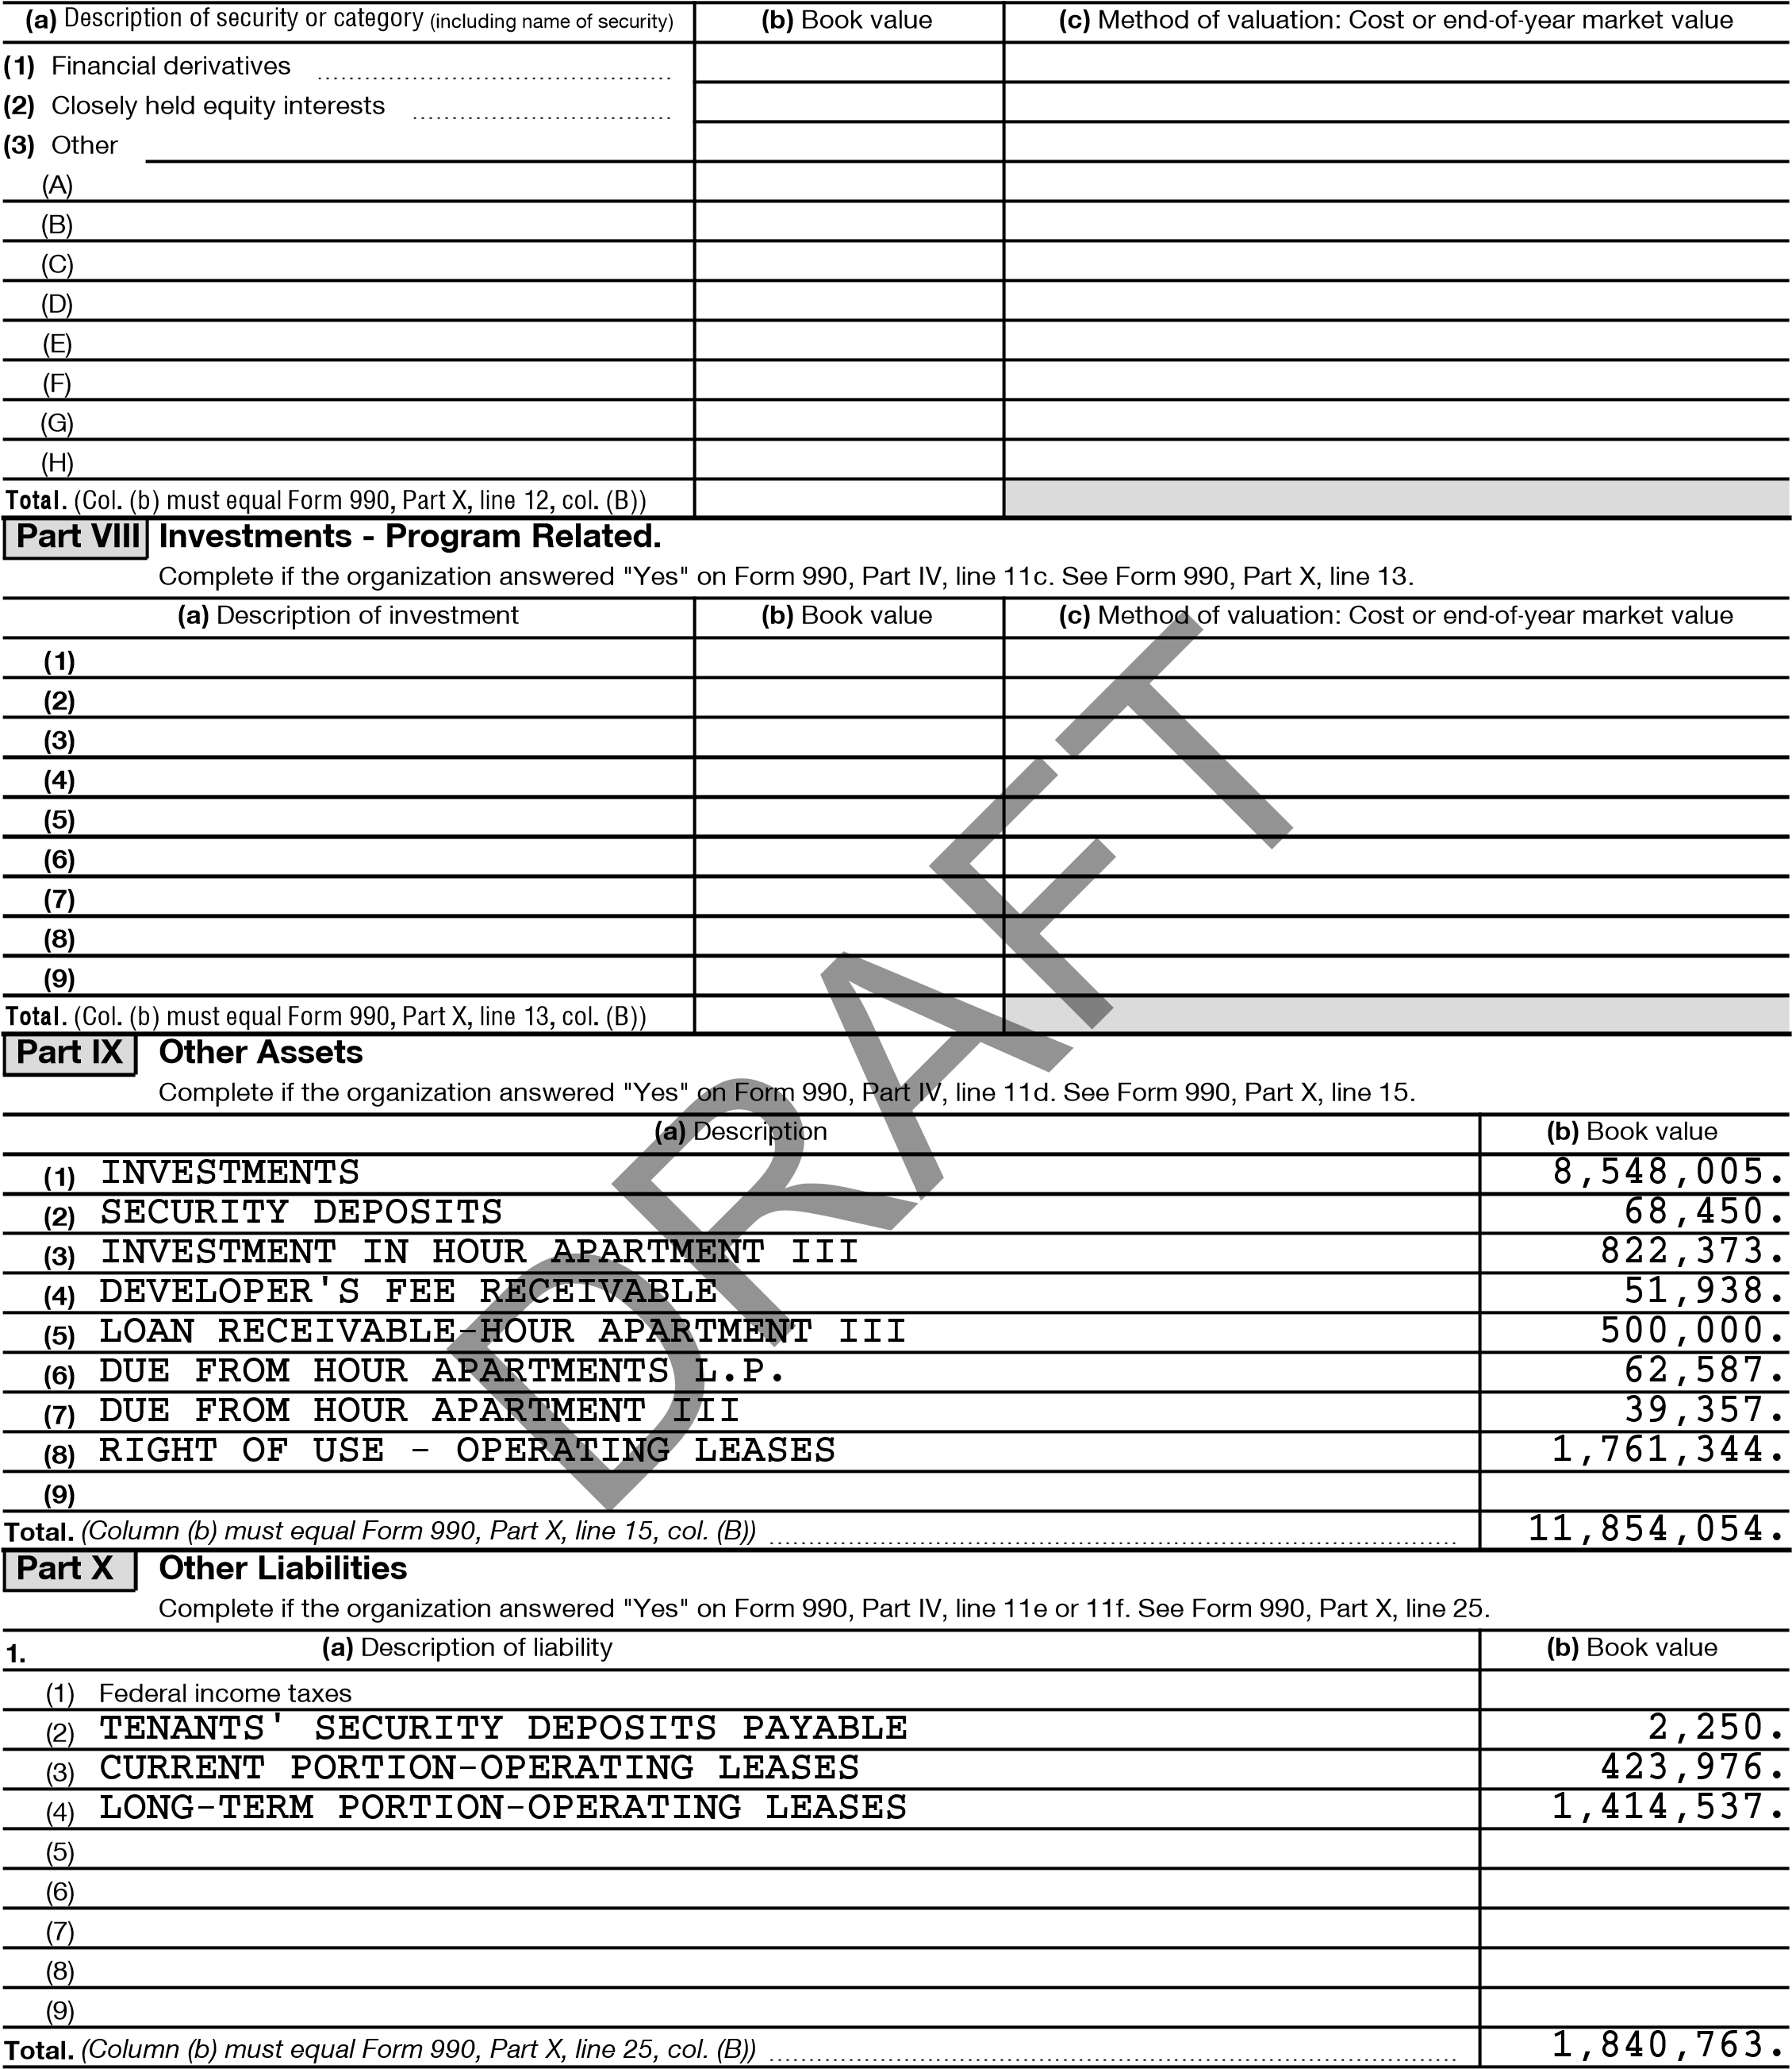
2. Liability for uncertain tax positions. In Part XIII, provide the text of the footnote to the organization’s financial statements that reports the organization’s liability for uncertain tax positions under FASB ASC 740. Check here if the text of the footnote has been provided in Part XIII
Schedule D (Form 990) 2023
332053 09-28-23
4 Part XI Reconciliation of Revenue per Audited Financial Statements With Revenue per Return
Complete if the organization answered "Yes" on Form 990, Part IV, line 12a.
- Total revenue, gains, and other support per audited financial statements ~~~~~~~~~~~~~~~~~~~ 1 7,136,290.
- Amounts included on line 1 but not on Form 990, Part VIII, line 12: a Net unrealized gains (losses) on investments ~~~~~~~~~~~~~~~~~~ 2a 778,345. b Donated services and use of facilities ~~~~~~~~~~~~~~~~~~~~~~ 2b 4,000.
c Recoveries of prior year grants ~~~~~~~~~~~~~~~~~~~~~~~~~ 2c d Other (Describe in Part XIII.) ~~~~~~~~~~~~~~~~~~~~~~~~~~ 2d 37,551.
e Add lines 2a through 2d ~~~~~~~~~~~~~~~~~~~~~~~~~~~~~~~~~~~~~~~~~~~ 2e 819,896. 3 Subtract line 2e from line 1 ~~~~~~~~~~~~~~~~~~~~~~~~~~~~~~~~~~~~~~~~~~ 3 6,316,394.
4 Amounts included on Form 990, Part VIII, line 12, but not on line 1:

a Investment expenses not included on Form 990, Part VIII, line 7b ~~~~~~~~ 4a b Other (Describe in Part XIII.) ~~~~~~~~~~~~~~~~~~~~~~~~~~ 4b c Add lines 4a and 4b ~~~~~~~~~~~~~~~~~~~~~~~~~~~~~~~~~~~~~~~~~~~~~ 4c 0.

5 Total revenue. Add lines 3 and 4c. (This must equal Form 990, Part I, line 12.) 5 6,316,394. Part XII Reconciliation of Expenses per Audited Financial Statements With Expenses per Return
Complete if the organization answered "Yes" on Form 990, Part IV, line 12a.
- Total expenses and losses per audited financial statements  - Amounts included on line 1 but not on Form 990, Part IX, line 25:  a Donated services and use of facilities ~~~~~~~~~~~~~~~~~~~~~~ b Prior year adjustments ~~~~~~~~~~~~~~~~~~~~~~~~~~~~~ c Other losses ~~~~~~~~~~~~~~~~~~~~~~~~~~~~~~~~~~ d Other (Describe in Part XIII.) ~~~~~~~~~~~~~~~~~~~~~~~~~~ e Add lines 2a through 2d ~~~~~~~~~~~~~~~~~~~~~~~~~~~~~ 3 Subtract line 2e from line 1 ~~~~~~~~~~~~~~~~~~~~~~~~~~~~  4 Amounts included on Form 990, Part IX, line 25, but not on line 1:  a Investment expenses not included on Form 990, Part VIII, line 7b ~~~~~~~~ b Other (Describe in Part XIII.) ~~~~~~~~~~~~~~~~~~~~~~~~~~ c Add lines 4a and 4b ~~~~~~~~~~~~~~~~~~~~~~~~~~~~~~~~~~~~~~~~~~~~~  5 Total expenses. Add lines 3 and 4c. (This must equal Form 990, Part I, line 18.) |  | ~~~~~~~~~~~~~~~~~~~~~~~~~~  2a | 4,000. | 1 | 6,982,653.
 |  | ~~~~~~~~~~~~~~~~~~~~~~~~~~  2a | 4,000. |  | 41,551.
 |  | 2b |  |  | 41,551.
 |  | 2c |  |  | 41,551.
 |  | 2d | 37,551. |  | 41,551.
 |  | ~~~  ~~~  4a | ~~~~~~~~~~~  ~~~~~~~~~~~ | 2e | 41,551.
 |  | ~~~  ~~~  4a | ~~~~~~~~~~~  ~~~~~~~~~~~ | 3 | 6,941,102.
 |  | ~~~  ~~~  4a | ~~~~~~~~~~~  ~~~~~~~~~~~ |  | 0.
 |  | 4b |  |  | 0.
 |  |  |  | 4c | 0.
 |  |  |  | 5 | 6,941,102.
Part XIII | Supplemental Information
Provide the descriptions required for Part II, lines 3, 5, and 9; Part III, lines 1a and 4; Part IV, lines 1b and 2b; Part V, line 4; Part X, line 2; Part XI, lines 2d and 4b; and Part XII, lines 2d and 4b. Also complete this part to provide any additional information.
PART XI, LINE 2D - OTHER ADJUSTMENTS:
DIRECT FUNDRAISING EXPENSE AGAINST FUNDRAISING INCOME 37,551.
PART XII, LINE 2D - OTHER ADJUSTMENTS:
DIRECT FINDRAISING EXPENSE AGAINST FUNDRAISING INCOME 37,551.

332054 09-28-23 Schedule D (Form 990) 2023

SCHEDULE G  (Form 990)  Department of the Treasury  Internal Revenue Service | Supplemental Information Regarding Fundraising or Gaming Activities  Complete if the organization answered "Yes" on Form 990, Part IV, line 17, 18, or 19, or if the organization entered more than $15,000 on Form 990-EZ, line 6a.  Attach to Form 990 or Form 990-EZ.  Go to www.irs.gov/Form990 for instructions and the latest information. |  | OMB No. 1545-0047
 |  |  | 2023
 |  |  | Open to Public Inspection
Name of the organizatio | n | Employer identification number
 | HOUR CHILDREN, INC. | **-***7412
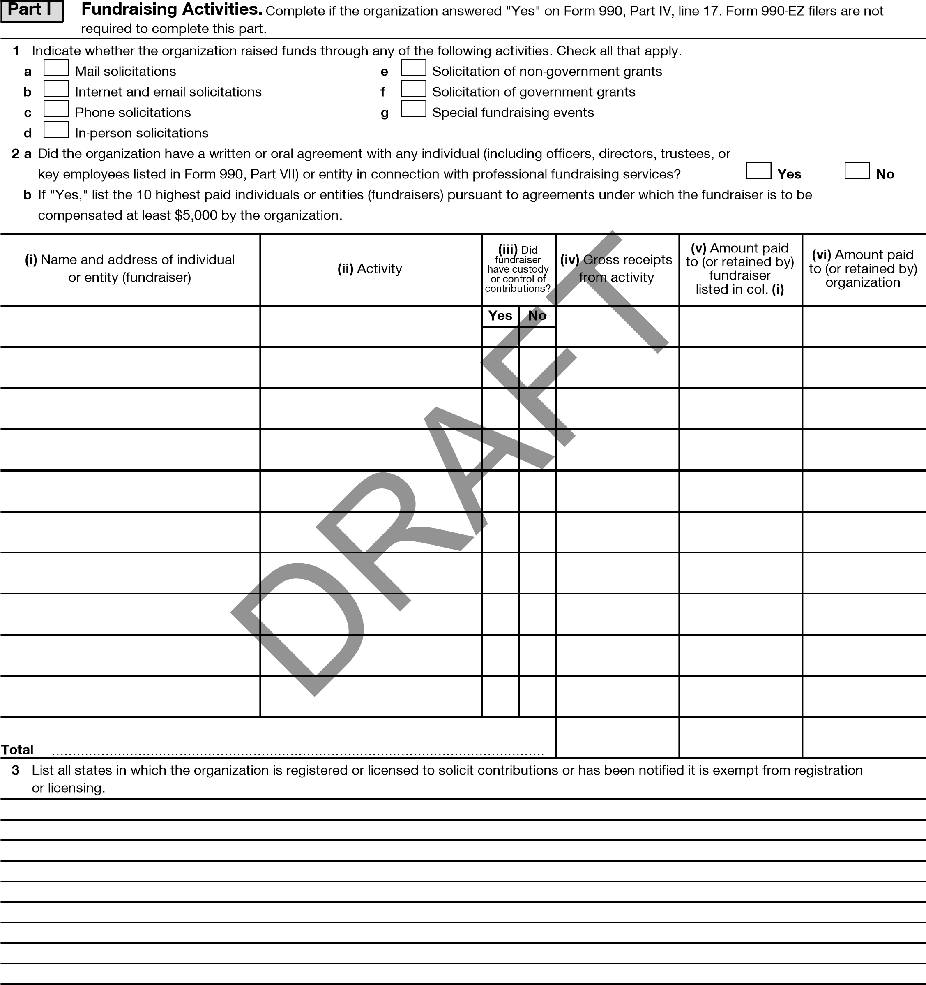

For Paperwork Reduction Act Notice, see the Instructions for Form 990 or 990-EZ. Schedule G (Form 990) 2023
LHA 332081 09-13-23
Schedule G (Form 990) 2023 2
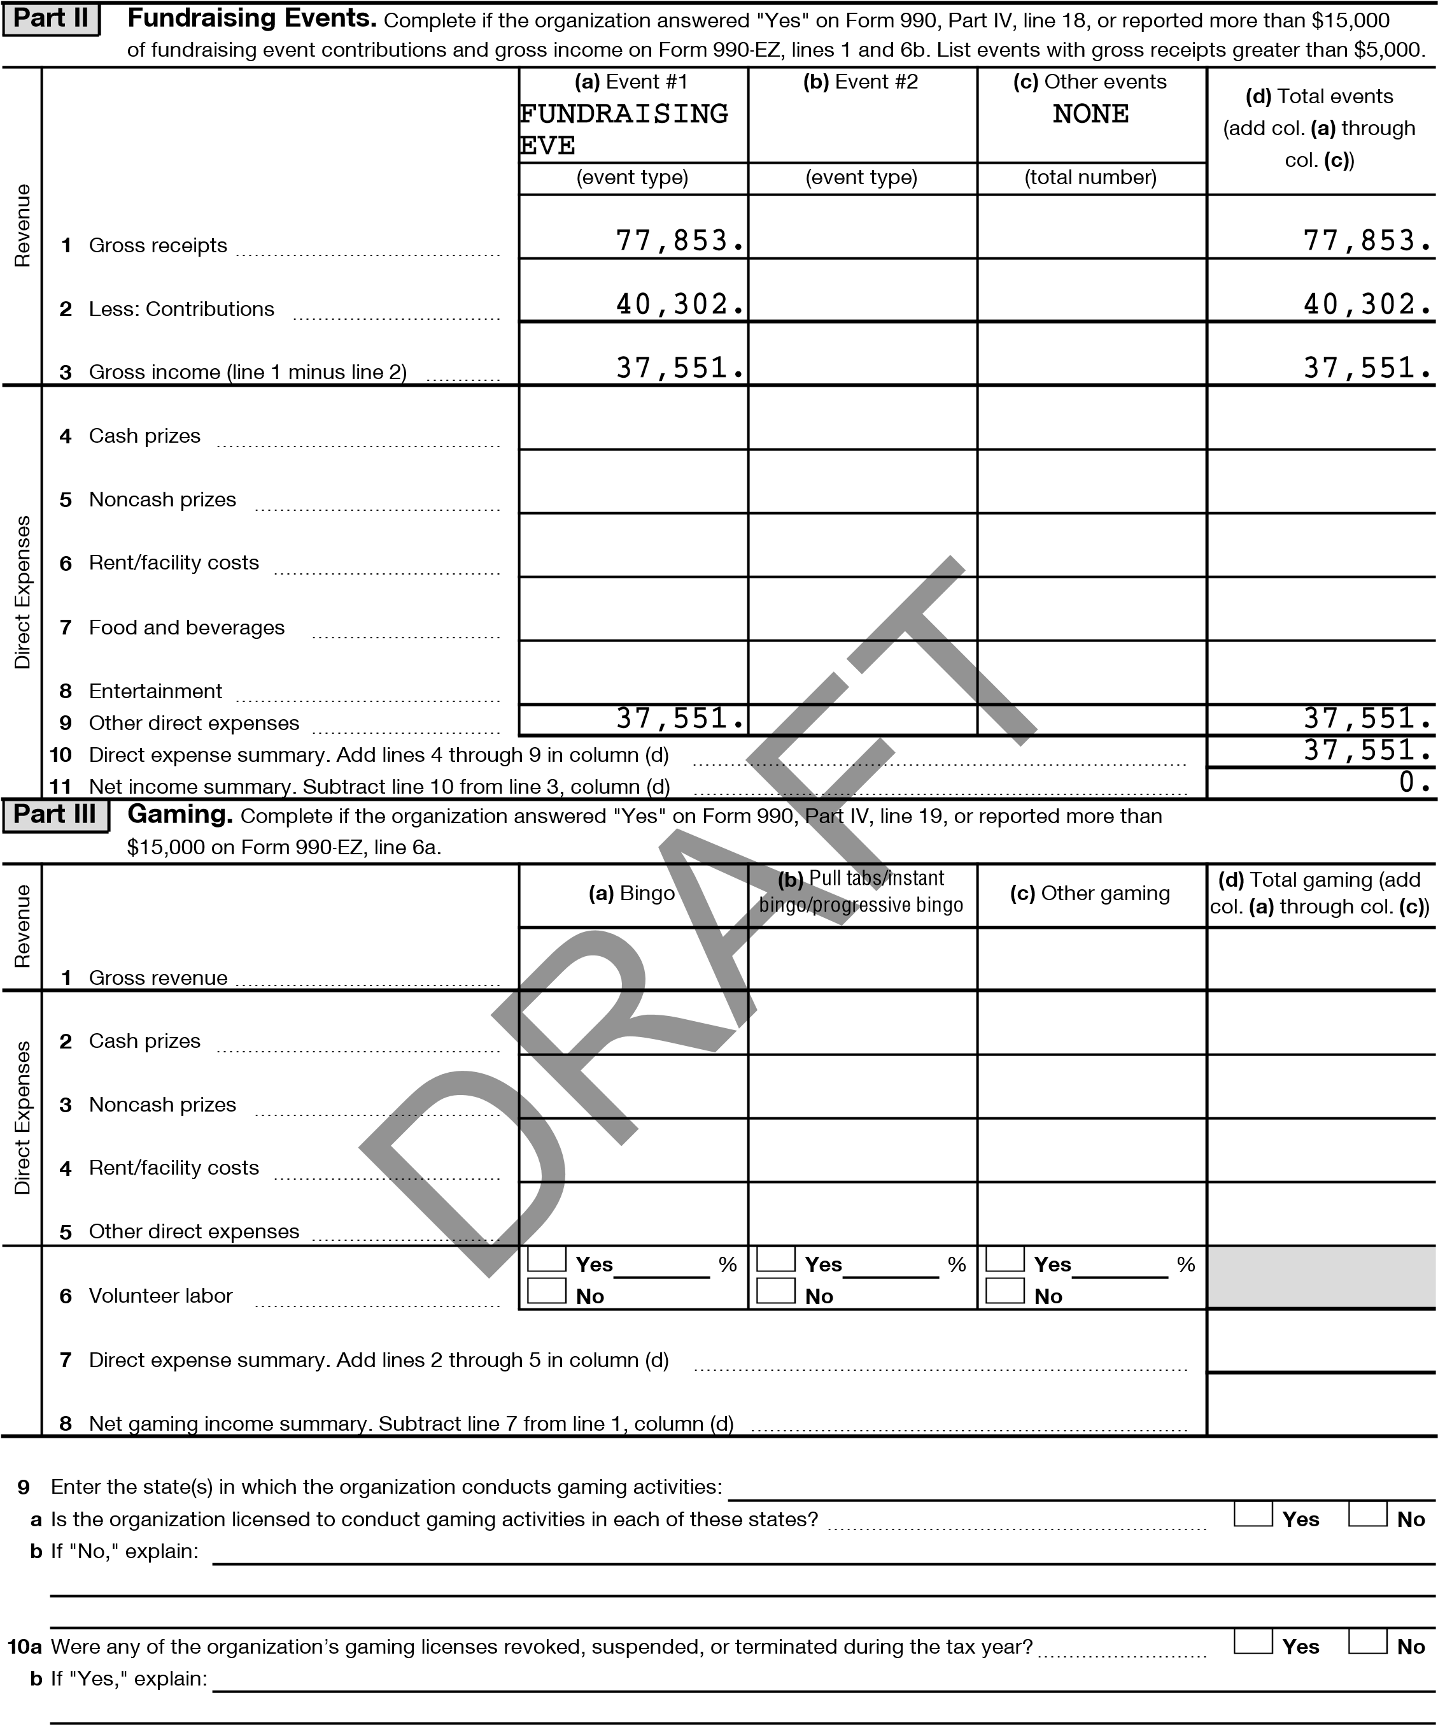

332082 09-13-23 Schedule G (Form 990) 2023 Schedule G (Form 990) 2023 3
- Does the organization conduct gaming activities with nonmembers?~~~~~~~~~~~~~~~~~~~~~~~~~~~ Yes No
- Is the organization a grantor, beneficiary or trustee of a trust, or a member of a partnership or other entity formed
to administer charitable gaming?~~~~~~~~~~~~~~~~~~~~~~~~~~~~~~~~~~~~~~~~~~~~ Yes No
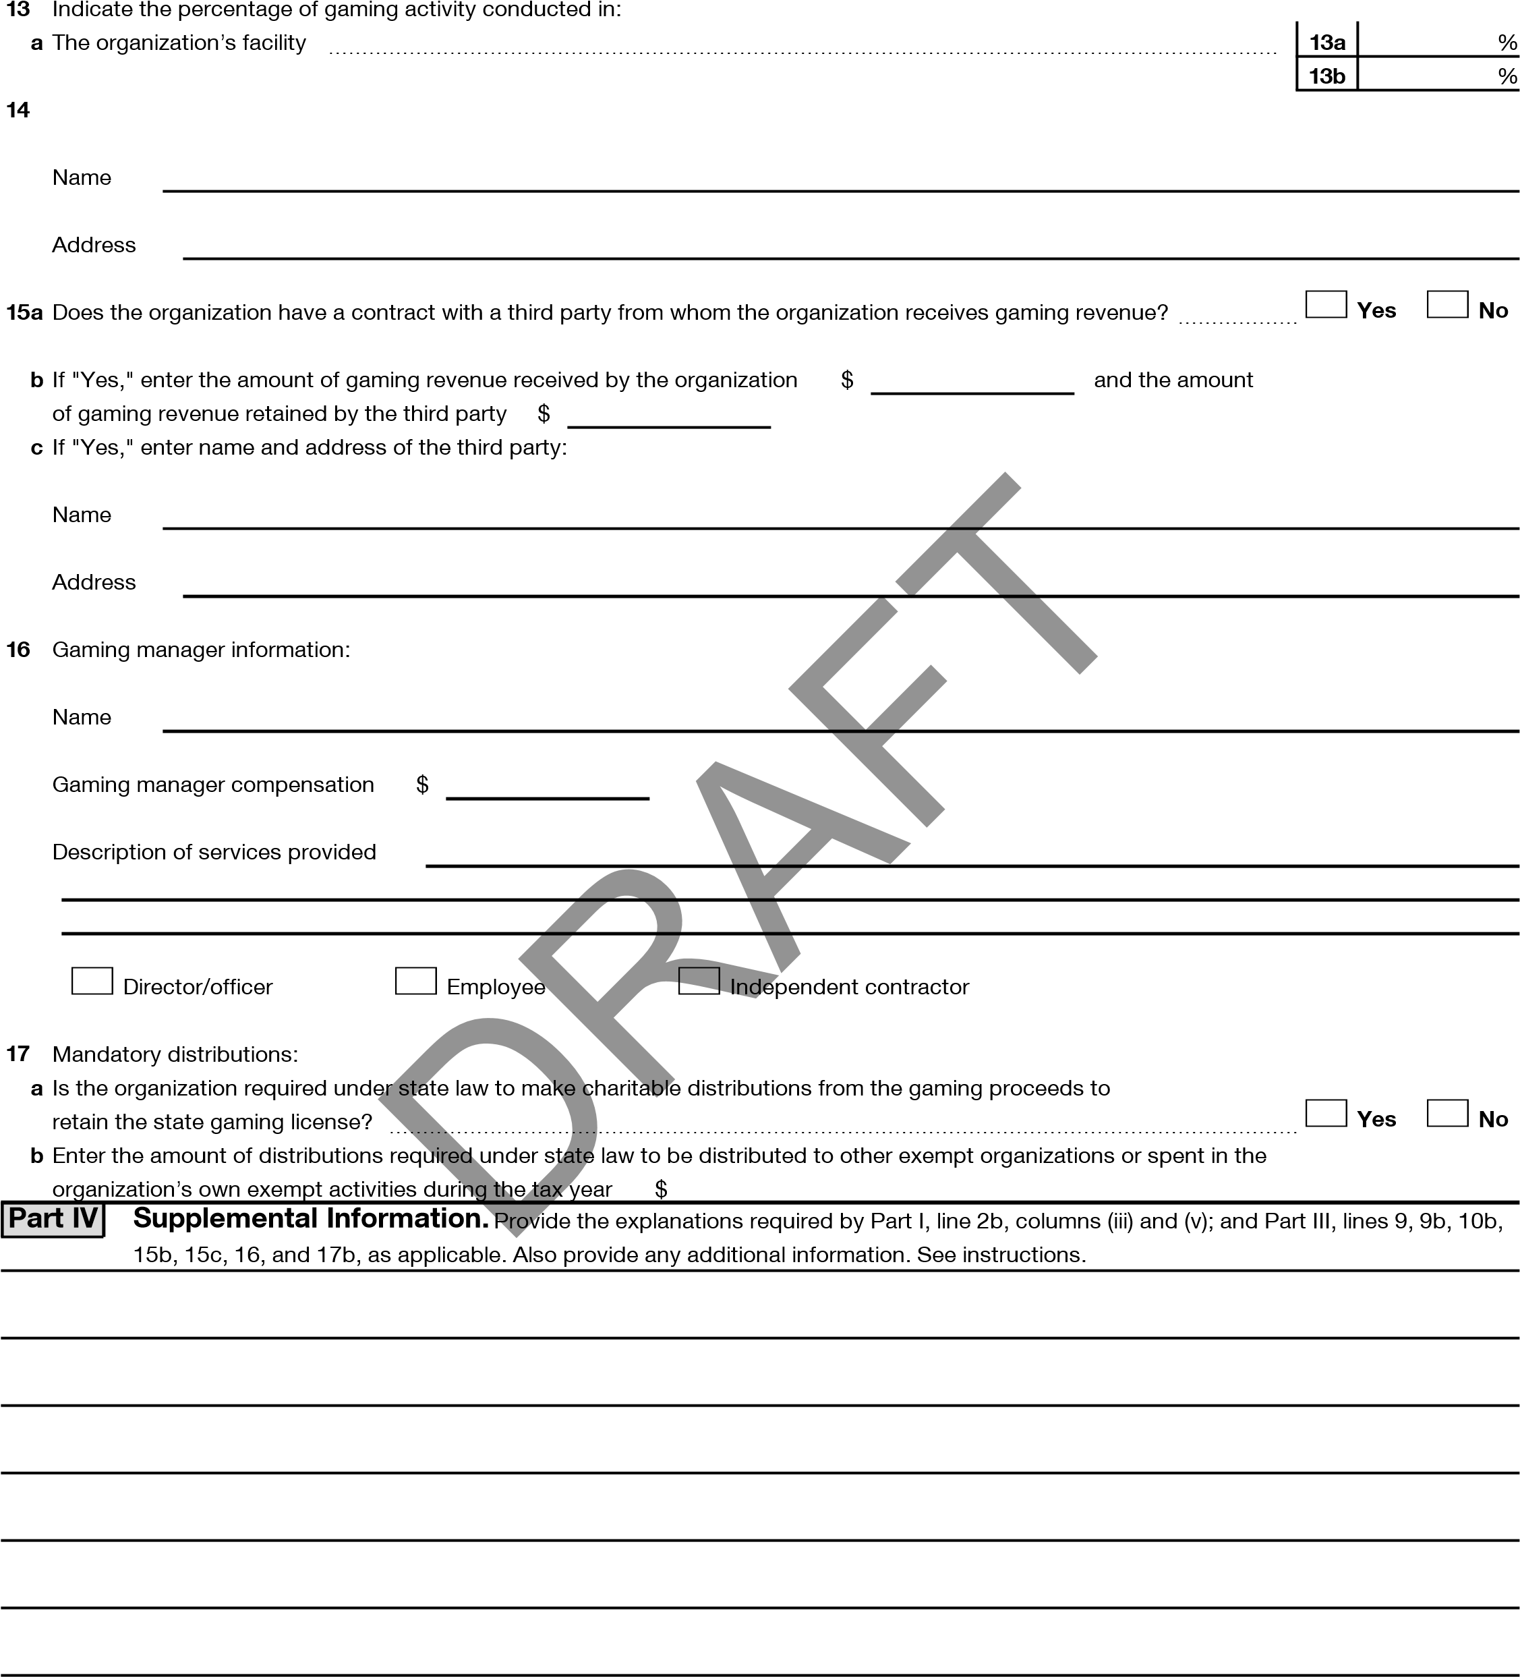
b An outside facility ~~~~~~~~~~~~~~~~~~~~~~~~~~~~~~~~~~~~~~~~~~~~~~~~~~~
Enter the name and address of the person who prepares the organization’s gaming/special events books and records:

- 09-13-23 Schedule G (Form 990) 2023 Schedule G (Form 990) 4
Part IV | Supplemental Information (continued)

DRAFT

Schedule G (Form 990)
- 04-01-23

SCHEDULE J Compensation Information ^{OMB No. 1545-0047}
(Form 990) For certain Officers, Directors, Trustees, Key Employees, and Highest 2023
Compensated Employees
Complete if the organization answered "Yes" on Form 990, Part IV, line 23.
Department of the Treasury Attach to Form 990. ^{Open to Public}
Internal Revenue Service Go to www.irs.gov/Form990 for instructions and the latest information. ^{Inspection}
Name of the organization Employer identification number
HOUR CHILDREN, INC. **-***7412

Part I Questions Regarding Compensation
Yes No
1a Check the appropriate box(es) if the organization provided any of the following to or for a person listed on Form 990, Part VII, Section A, line 1a. Complete Part III to provide any relevant information regarding these items.
First-class or charter travel Housing allowance or residence for personal use
Travel for companions Payments for business use of personal residence
Tax indemnification and gross-up payments Health or social club dues or initiation fees
Discretionary spending account Personal services (such as maid, chauffeur, chef)
b If any of the boxes on line 1a are checked, did the organization follow a written policy regarding payment or reimbursement or provision of all of the expenses described above? If "No," complete Part III to explain~~~~~~~~~~~ 1b
- Did the organization require substantiation prior to reimbursing or allowing expenses incurred by all directors, trustees, and officers, including the CEO/Executive Director, regarding the items checked on line 1a? ~~~~~~~~~~~~ 2
- Indicate which, if any, of the following the organization used to establish the compensation of the organization’s CEO/Executive Director. Check all that apply. Do not check any boxes for methods used by a related organization to establish compensation of the CEO/Executive Director, but explain in Part III.
Compensation committee Written employment contract
Independent compensation consultant Compensation survey or study
Form 990 of other organizations Approval by the board or compensation committee
- During the year, did any person listed on Form 990, Part VII, Section A, line 1a, with respect to the filing organization or a related organization:

a Receive a severance payment or change-of-control payment? ~~~~~~~~~~~~~~~~~~~~~~~~~~~~~~~ 4a X b Participate in or receive payment from a supplemental nonqualified retirement plan? ~~~~~~~~~~~~~~~~~~~~ 4b X c Participate in or receive payment from an equity-based compensation arrangement? ~~~~~~~~~~~~~~~~~~~~ 4c X
If "Yes" to any of lines 4a-c, list the persons and provide the applicable amounts for each item in Part III.
Only section 501(c)(3), 501(c)(4), and 501(c)(29) organizations must complete lines 5-9.
5 For persons listed on Form 990, Part VII, Section A, line 1a, did the organization pay or accrue any compensation contingent on the revenues of:
a The organization? ~~~~~~~~~~~~~~~~~~~~~~~~~~~~~~~~~~~~~~~~~~~~~~~~~~~~~ 5a X b Any related organization? ~~~~~~~~~~~~~~~~~~~~~~~~~~~~~~~~~~~~~~~~~~~~~~~~~ 5b X
If "Yes" on line 5a or 5b, describe in Part III.
6 For persons listed on Form 990, Part VII, Section A, line 1a, did the organization pay or accrue any compensation contingent on the net earnings of:
a The organization? ~~~~~~~~~~~~~~~~~~~~~~~~~~~~~~~~~~~~~~~~~~~~~~~~~~~~~ 6a X b Any related organization? ~~~~~~~~~~~~~~~~~~~~~~~~~~~~~~~~~~~~~~~~~~~~~~~~~ 6b X
If "Yes" on line 6a or 6b, describe in Part III.
- For persons listed on Form 990, Part VII, Section A, line 1a, did the organization provide any nonfixed payments
not described on lines 5 and 6? If "Yes," describe in Part III~~~~~~~~~~~~~~~~~~~~~~~~~~~~~~~~~ 7 X
- Were any amounts reported on Form 990, Part VII, paid or accrued pursuant to a contract that was subject to the initial contract exception described in Regulations section 53.4958-4(a)(3)? If "Yes," describe in Part III ~~~~~~~~~~~ 8 X
- If "Yes" on line 8, did the organization also follow the rebuttable presumption procedure described in
Regulations section 53.4958-6(c)? 9
For Paperwork Reduction Act Notice, see the Instructions for Form 990. Schedule J (Form 990) 2023
LHA 332111 11-06-23

332112 11-06-23
2
Part II
Officers, Directors, Trustees, Key Employees, and Highest Compensated Employees.
Note:
(
B)
C)
(
D)
(
(
E)
(
F)
(
A)
(
i)
(
ii)
(
iii)
i
(
)
)
(
ii
)
i
(
)
ii
(
i
(
)
)
ii
(
(
i
)
(
)
ii
)
(
i
)
ii
(
)
i
(
)
ii
(
i
(
)
)
ii
(
)
i
(
(
ii
)
(
i
)
ii
)
(
(
i
)
)
(
ii
(
)
i
(
ii
)
(
i
)
ii
)
(
(
i
)
)
(
ii
(
)
i
(
ii
)
(
i
)
(
ii
)
(
i
)
(
ii
)
Schedule J (Form 990) 2023
Schedule J (Form 990) 2023
Page
Use duplicate copies if additional space is needed.
For each individual whose compensation must be reported on Schedule J, report compensation from the organization on row (i) and from related organizations, described in the instructions, on row (ii).
Do not list any individuals that aren’t listed on Form 990, Part VII.
The sum of columns (B)(i)-(iii) for each listed individual must equal the total amount of Form 990, Part VII, Section A, line 1a, applicable column (D) and (E) amounts for that individual.
Breakdown of W-2 and/or 1099-MISC and/or 1099-NEC
compensation
Retirement and
other deferred
compensation
Nontaxable
benefits
Total of columns
(
B)(i)-(D
)
Compensation
in column (B)
reported as deferred
on prior Form 990
Name and Title
Base
compensation
Bonus &
incentive
compensation
Other
reportable
compensation
HOUR CHILDREN, INC.
**-***7412
(1)
ALETHEA TAYLOR
212,180.
0.
16,871.
0.
229,051.
0.
0.
EXECUTIVE DIRECTOR
0.
0.
0.
0.
0.
0.
0.
PATRICIA DALY
(2)
148,526.
0.
15,162.
0.
0.
163,688.
0.
DIRECTOR DEVELOPMENT
0.
0.
0.
0.
0.
0.
0.
34
DRAFT
332113 11-06-23
3
Part III
Supplemental Information
Schedule J (Form 990) 2023
Schedule J (Form 990) 2023
Page
Provide the information, explanation, or descriptions required for Part I, lines 1a, 1b, 3, 4a, 4b, 4c, 5a, 5b, 6a, 6b, 7, and 8, and for Part II. Also complete this part for any additional information.
HOUR CHILDREN, INC.
**-***7412
35
DRAFT

SCHEDULE O  (Form 990)  Department of the Treasury  Internal Revenue Service | Supplemental Information to Form 990 or 990-EZ  Complete to provide information for responses to specific questions on Form 990 or 990-EZ or to provide any additional information.  Attach to Form 990 or Form 990-EZ.  Go to www.irs.gov/Form990 for the latest information. |  | OMB No. 1545-0047
 |  |  | 2023
 |  |  | Open to Public Inspection
Name of the organizatio | n | Employer identification number
 | HOUR CHILDREN, INC. | **-***7412
FORM 990, PART I, LINE 1, DESCRIPTION OF ORGANIZATION MISSION:
SUCESSFULLY REJOIN THE COMMUNITY, REUIFY WITH THEIR FAMILIES,AND BUILD
HEALTHY, INDEPENDENT, AND SECURE LIVES. HOUR NAME ACKNOWLEDGES HE KEY
HOURS OF HER ARREST, THE HOUR OF THEIR VISIT, AND THE HOUR OF THEIR REUNIFICATION. HOUR CHILDREN’S SUPPORTIVE PROGRAM HELPS JUSTICE INVOLVED FAMILIES REMAIN CONNECTED DURING A MOTHER’S IMPRISONMENT AND BUILD POSITIVE, HOPE- FILLED LIVES AFTER HER RELEASE.
DRAFT
FORM 990, PART III, LINE 4A, PROGRAM SERVICE ACCOMPLISHMENTS:
PROGRAM,CHILDREN’S CENTER, ADVOCACY, PARENTING AND DOMESTIC VIOLENCE
PROGRAMS. AN ADVOCACY PROGRAM IS ALSO RUN IN ROSE M. SINGER AT RIKERS ISLAND. OUTREACH SERVICES ARE PROVIDED FOR WOMEN ON WORK RELEASE AT EDGECOMBE CORRECTIONAL FACILITY.
FORM 990, PART VI, SECTION B, LINE 11B:
THE ORGANIZATION’S 990 IS REVIEWED BY ITS EXECUTIVE DIRECTOR AND FINANCE/AUDIT COMMITTEE OF THE BOAD BEFORE IT IS ISSUED AND FILED
FORM 990, PART VI, SECTION B, LINE 12C:
THE ORGANIZATION REGULARLY ASKS BOARD MEMBERS TO CONTINUALLY MONITOR ANDDISCLOSE INTERESTS AND REMINDS THIS REQUIREMENT AT BOARD MEETINGS.
FORM 990, PART VI, SECTION B, LINE 15:
THE ORGANIZATION’S PROCESS FOR DETERMINING COMPENSATION IS PERFORMED BYBOARD OF DIRECTORS.THE ORGANIZATION’S PROCESS OF DETERMINING COMPENSATION
IS PERFORMED BY THEBOARD OF DIRECTORS.

For Paperwork Reduction Act Notice, see the Instructions for Form 990 or 990-EZ. Schedule O (Form 990) 2023
LHA 332211 11-14-23
36
18060716 758504 HOURCHILDRE 2023.06000 HOUR CHILDREN, INC. HOURCHI1
Schedule O (Form 990) 2023 Page 2
332212 11-14-23
Employer identification number
Schedule O (Form 990) 2023
Name of the organization
HOUR CHILDREN, INC.
**-***7412
FORM 990, PART VI, SECTION C, LINE 19:
THE ORGANIZATION MAKES ITS GOVERNING DOCUMENTS, CONFLICT OF INTEREST POLICY
AND FINANCIAL STATEMENTS AVAILABLE TO THE PUBLIC UPON REQUEST.
AMEDEDED RETURN EXPLANATION
AFTER TIMELY FILING THE TAX RETURN FOR THE YEAR ENDED JUNE 30, 2024 BY
MAY 15, 2025, THE ORGANIZATION OBTAINED ADDITIONAL INFOMRATION, WHICH
REQUIRES TO AMEND THE RETURN. THE FOLLOWING CHANGES ARE BEING MADE.
REVENUE
CHILD CARE WAS CHANGED TO $11,228 FROM $29,228
GROSS RENTS WAS CHANGED TO $78,282 FROM $136,282
DONATED SERIVES REVENUE TO $4,000 FROM $0
EXPENSES
OTHER EXPENSE WAS CHANGED TO $507,484 FROM $457,484.
DONAATED SERIVES EXPENSE TO $4,000 FROM $0
DUE TO CHANGES IN REVENUE AND EXPENSES AS SHOWN ABOVE, FORM 990 OF PART
I, PART III, PART VIII, PART IX, PART X, PART IX, SCHEDULE A OF PART
II, AND SCHEDULE D OF PART XI ARE CHANGED ACCORDINGLY.
DRAFT

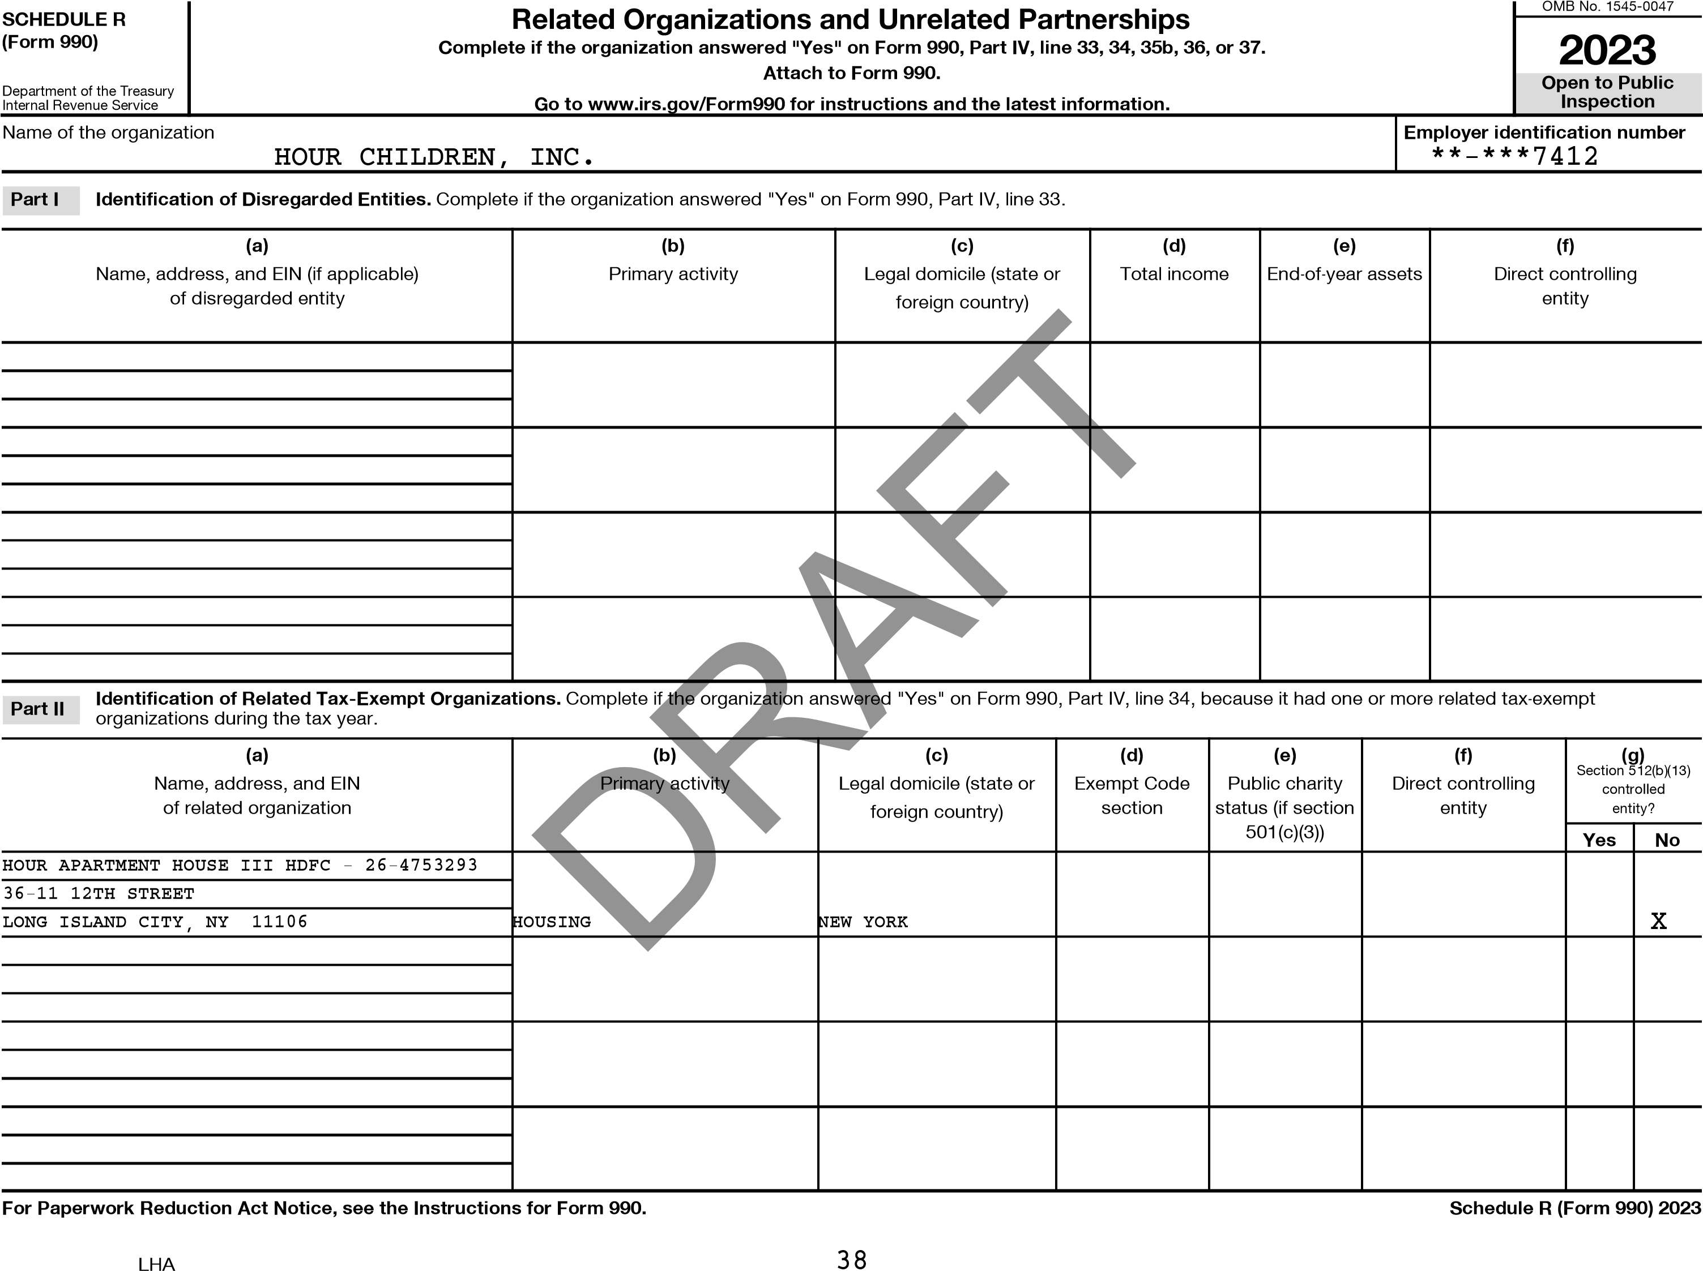
(a)  Name, address, and EIN of related organization | (b)  Primary activity | (c)  Legal domicile  (state or foreign country) | (d)  Direct controlling entity | (e)  Predominant income  (related, unrelated, excluded from tax under sections 512-514) | (f)  Share of total income | (g)  Share of end-of-year assets | (h)  Disproportionate allocations? |  | (i)  Code V-UBI amount in box  20 of Schedule  K-1 (Form 1065) | (j)  General or managing partner? |  | (k)  Percentage ownership
 |  |  |  |  |  |  | Yes | No |  | Yes | No | (k)  Percentage ownership
 |  | NY |  |  |  |  |  | X | N/A |  | X
HOUR APT LP - 02-0732009
36-11 12TH STREET
LONG ISLAND CITY, NY 11106
HOUR APARTMENT HOUSE III, LP |  | NY |  |  |  |  |  | X | N/A |  | X
- 37-1613485, 36-11 12TH
STREET, LONG ISLAND CITY, NY
11106
(a)  Name, address, and EIN of related organization | (b)  Primary activity | (c)  Legal domicile  (state or foreign country) | (d)  Direct controlling entity | (e)  Type of entity  (C corp, S corp, or trust) | (f)  Share of total income | (g)  Share of end-of-year assets | (h)  Percentage ownership | (i)  Section 512(b)(13) controlled entity?
 |  |  |  |  |  |  |  | Yes | No
HOUR APT GP INC - 02-0732005 | HOUSING | NY |  |  |  |  |  |  | X
36-11 12TH STREET
LONG ISLAND CITY, NY 11106
HOUR APARTMENT HOUSE III GP - 36-4681643 | HOUSING | NY |  |  |  |  |  |  | X
36-11 12TH STREET
LONG ISLAND CITY, NY 11106
Schedule R (Form 990) 2023 HOUR CHILDREN, INC. **-***7412 _{Page 2}
39
DRAFT
Part III Identification of Related Organizations Taxable as a Partnership. Complete if the organization answered "Yes" on Form 990, Part IV, line 34, because it had one or more related organizations treated as a partnership during the tax year.
Part IV Identification of Related Organizations Taxable as a Corporation or Trust. Complete if the organization answered "Yes" on Form 990, Part IV, line 34, because it had one or more related organizations treated as a corporation or trust during the tax year.
Schedule R (Form 990) 2023
Schedule R (Form 990) 2023 HOUR CHILDREN, INC. **-***7412 _{Page 3}
Part V
Transactions With Related Organizations. Complete if the organization answered "Yes" on Form 990, Part IV, line 34, 35b, or 36.
Note: Complete line 1 if any entity is listed in Parts II, III, or IV of this schedule. |  | Yes | No
1 During the tax year, did the organization engage in any of the following transactions with one or more related organizations listed in Parts II-IV?
a Receipt of (i) interest, (ii) annuities, (iii) royalties, or (iv) rent from a controlled entity ~~~~~~~~~~~~~~~~~~~~~~~~~~~~~~~~~~~~~~~~~~~~~ b Gift, grant, or capital contribution to related organization(s) ~~~~~~~~~~~~~~~~~~~~~~~~~~~~~~~~~~~~~~~~~~~~~~~~~~~~~~~~~ c Gift, grant, or capital contribution from related organization(s) ~~~~~~~~~~~~~~~~~~~~~~~~~~~~~~~~~~~~~~~~~~~~~~~~~~~~~~~~ d Loans or loan guarantees to or for related organization(s) ~~~~~~~~~~~~~~~~~~~~~~~~~~~~~~~~~~~~~~~~~~~~~~~~~~~~~~~~~~ e Loans or loan guarantees by related organization(s) ~~~~~~~~~~~~~~~~~~~~~~~~~~~~~~~~~~~~~~~~~~~~~~~~~~~~~~~~~~~~~
f Dividends from related organization(s)~~~~~~~~~~~~~~~~~~~~~~~~~~~~~~~~~~~~~~~~~~~~~~~~~~~~~~~~~~~~~~~~~~~~ g Sale of assets to related organization(s) ~~~~~~~~~~~~~~~~~~~~~~~~~~~~~~~~~~~~~~~~~~~~~~~~~~~~~~~~~~~~~~~~~~~ h Purchase of assets from related organization(s) ~~~~~~~~~~~~~~~~~~~~~~~~~~~~~~~~~~~~~~~~~~~~~~~~~~~~~~~~~~~~~~~ i Exchange of assets with related organization(s) ~~~~~~~~~~~~~~~~~~~~~~~~~~~~~~~~~~~~~~~~~~~~~~~~~~~~~~~~~~~~~~~ j Lease of facilities, equipment, or other assets to related organization(s) ~~~~~~~~~~~~~~~~~~~~~~~~~~~~~~~~~~~~~~~~~~~~~~~~~~~
k Lease of facilities, equipment, or other assets from related organization(s) ~~~~~~~~~~~~~~~~~~~~~~~~~~~~~~~~~~~~~~~~~~~~~~~~~~ l Performance of services or membership or fundraising solicitations for related organization(s) ~~~~~~~~~~~~~~~~~~~~~~~~~~~~~~~~~~~~~~~~ m Performance of services or membership or fundraising solicitations by related organization(s) ~~~~~~~~~~~~~~~~~~~~~~~~~~~~~~~~~~~~~~~~ n Sharing of facilities, equipment, mailing lists, or other assets with related organization(s) ~~~~~~~~~~~~~~~~~~~~~~~~~~~~~~~~~~~~~~~~~~~ o Sharing of paid employees with related organization(s) ~~~~~~~~~~~~~~~~~~~~~~~~~~~~~~~~~~~~~~~~~~~~~~~~~~~~~~~~~~~
p Reimbursement paid to related organization(s) for expenses ~~~~~~~~~~~~~~~~~~~~~~~~~~~~~~~~~~~~~~~~~~~~~~~~~~~~~~~~~ q Reimbursement paid by related organization(s) for expenses~~~~~~~~~~~~~~~~~~~~~~~~~~~~~~~~~~~~~~~~~~~~~~~~~~~~~~~~~
r Other transfer of cash or property to related organization(s) ~~~~~~~~~~~~~~~~~~~~~~~~~~~~~~~~~~~~~~~~~~~~~~~~~~~~~~~~~ s Other transfer of cash or property from related organization(s)
 | 1a |  | X
 | 1b |  | X
 | 1c |  | X
 | 1d |  | X
 | 1e |  | X
 | 1f |  | X
 | 1g |  | X
 | 1h |  | X
 | 1i |  | X
 | 1j |  | X
 | 1k |  | X
 | 1l | X
 | 1m |  | X
 | 1n |  | X
 | 1o |  | X
 | 1p |  | X
 | 1q | X
 | 1r |  | X
 | 1s |  | X
(a) | (b) | (c) | (d)
Name of related organization | Transaction type (a-s) | Amount involved | Method of determining amount involved
(1) HOUR APARTMENT HOUSE III, LP | Q | 85,668.
(2) HOUR APARTMENT HOUSE III, LP | I | 85,071.
(3)
(4)
(5)
(6)
2 If the answer to any of the above is "Yes," see the instructions for information on who must complete this line, including covered relationships and transaction thresholds.
40 Schedule R (Form 990) 2023
Are all
partners sec.
501(c)(3)
orgs.?
Dispropor-
tionate
allocations?
General or
managing
partner?
No
Yes
Yes
No
N
Yes
4
Part VI
Unrelated Organizations Taxable as a Partnership.
(
a
)
(
b
)
c
)
(
d
)
(
(
e
)
(
f
)
g
)
(
(
i
)
(
j
)
(
k
)
)
(
h
o
Schedule R (Form 990) 2023
Predominant income
(
related, unrelated,
excluded from tax under
sections 512-514)
Code V-UBI
amount in box 20
of Schedule K-1
(
Form
1065)
Schedule R (Form 990) 2023
Page
Complete if the organization answered "Yes" on Form 990, Part IV, line 37.
Provide the following information for each entity taxed as a partnership through which the organization conducted more than five percent of its activities (measured by total assets or gross revenue)
that was not a related organization. See instructions regarding exclusion for certain investment partnerships.
Name, address, and EIN
of entity
Primary activity
Legal domicile
(
state or foreign
country)
Share of
total
income
Share of
end-of-year
assets
Percentage
ownership
HOUR CHILDREN, INC.
**-***7412
41
DRAFT

Schedule R (Form 990) 2023 HOUR CHILDREN, INC. **-***7412 _{Page 5}
Provide additional information for responses to questions on Schedule R. See instructions.
Part VII
Supplemental Information
DRAFT
332165 09-28-23 Schedule R (Form 990) 2023
42
18060716 758504 HOURCHILDRE 2023.06000 HOUR CHILDREN, INC. HOURCHI1

